CATERPILLAR cp563c Vibratory Compactor
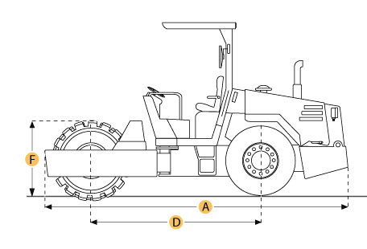

Selected Dimensions
Dimensions
B. Width Over Tires | 7.6 ft in | 2316.5 mm
C. Height to Top of Cab | 10.2 ft in | 3100 mm
D. Wheelbase | 9 ft in | 2740 mm
E. Ground Clearance | 19 in | 483 mm
Drum
F. Drum Diameter | 61 in | 1549 mm

Specification
Engine
Model | 3116T
Gross Power | 145 hp | 108.1 kw
Displacement | 402.8 cu in | 6.6 L
Operational
Operating Weight | 25727.9 lb | 11670 kg
Fuel Capacity | 58.1 gal | 220 L
Engine Oil Capacity | 5.3 gal | 20 L
Hydraulic System Fluid Capacity | 29.1 gal | 110 L
Max Speed | 8 mph | 12.8 km/h
Tires | 23.1 x 26 - 8ply
Drum
Drum Width | 83.9 in | 2130 mm
Drum Diameter | 61 in | 1549 mm
Vibration Frequency 1 | 30 Hz
Centrifugal Force - High | 53000 lb | 235.8 kN
Centrifugal Force - Low | 29700 lb | 132.1 kN
Dimensions
Overall Length w/ Blade | 17.3 ft in | 5258 mm
Width Over Tires | 7.6 ft in | 2316.5 mm
Height to Top of Cab | 10.2 ft in | 3100 mm
Wheelbase | 9 ft in | 2740 mm
Ground Clearance | 19 in | 483 mm

