CATERPILLAR pr450 Cold Planer
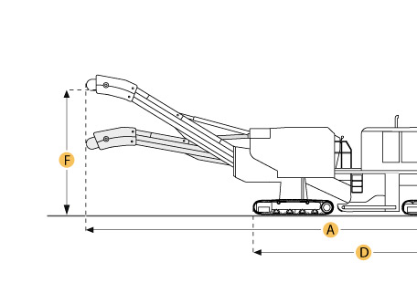

Selected Dimensions
Conveyor System
H. Discharge Conveyor Width | 30 in | 762 mm
Dimensions
A. Operating Length | 43.6 ft in | 13280 mm
B. Shipping Width | 9.4 ft in | 2870 mm
C. Shipping Height | 14 ft in | 4267 mm

Specification
Engine
Make | Caterpillar
Model | 3408
Gross Power | 450.6 hp | 336 kw
Displacement | 1098.4 cu in | 18 L
Operational
Operating Weight - Full Load | 56791.1 lb | 25760 kg
Fuel Capacity | 200 gal | 757.1 L
Water Spray System Fluid Capacity | 700 gal | 2649.8 L
Operating Speed | 175.9 ft/min | 53.6 m/min
Travel Speed | 2 mph | 3.2 km/h
Rotary Cutter
Cutting Width | 6.3 ft in | 1905 mm
Cutting Depth | 10 in | 254 mm
Number of Tools | 144
Conveyor System
Discharge Conveyor Width | 30 in | 762 mm
Tracks
Number of Track Units | 3
Front Track Width | 12 in | 305 mm
Rear Track Width | 12 in | 305 mm
Dimensions
Operating Length | 43.6 ft in | 13280 mm
Shipping Width | 9.4 ft in | 2870 mm
Shipping Height | 14 ft in | 4267 mm

