Caterpillar 140B Motor Grader
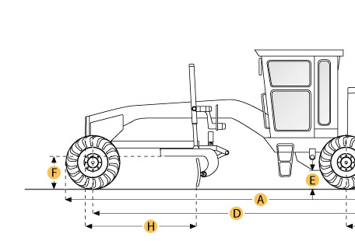

Selected Dimensions
Dimensions
A. Overall Length | 26.5 ft in | 8070 mm
B. Width Over Tires | 7.8 ft in | 2390 mm
C. Height to Top of Cab | 10.5 ft in | 3210 mm
D. Wheelbase | 20.1 ft in | 6140 mm
H. Blade Base | 9.1 ft in | 2760 mm

Specification
Engine
Make | Caterpillar
Model | 3306
Net Power Gear 5-6 | 150.2 hp | 112 kw
Max Power | 150.2 hp | 112 kw
Displacement | 640.7 cu in | 10.5 L
Operational
Std Operation Weight - Total | 30027 lb | 13620 kg
Fuel Capacity | 60 gal | 227 L
Tire Size | 14.0-24 (10PR) (G-2)
Transmission
Number of Gears - Forward | 6
Number of Gears - Reverse | 4
Max Speed - Forward | 23.4 mph | 37.6 km/h
Max Speed - Reverse | 15.9 mph | 25.6 km/h
Steering
Turning Radius | 38.1 ft in | 11.6 m
Moldboard
Moldboard Width | 13 ft in | 3960 mm
Moldboard Height | 27.6 in | 700 mm
Circle
Max Reach Outside Tires - Left | 94.5 in | 2400 mm
Max Reach Outside Tires - Right | 94.5 in | 2400 mm
Max Lift Above Ground | 14 in | 356 mm
Dimensions
Height to Top of Cab | 10.5 ft in | 3210 mm
Overall Length | 26.5 ft in | 8070 mm
Width Over Tires | 7.8 ft in | 2390 mm
Wheelbase | 20.1 ft in | 6140 mm
Blade Base | 9.1 ft in | 2760 mm

