CATERPILLAR 631e Motor Scraper
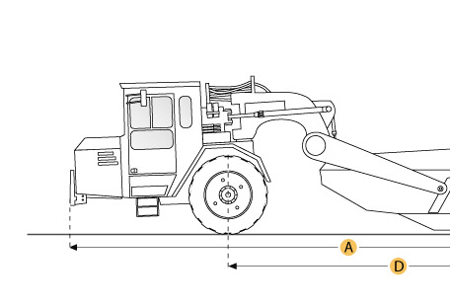

Selected Dimensions
Dimensions
A. Overall Length | 46.9 ft in | 14280 mm
B. Overall Width | 12.9 ft in | 3940 mm
C. Overall Height | 14.1 ft in | 4290 mm
D. Wheelbase | 28.8 ft in | 8770 mm

Specification
Tractor Engine
Make | Caterpillar
Model | 3408
Gross Power | 450 hp | 335.6 kw
Displacement | 1098.4 cu in | 18 L
Operational
Fuel Capacity | 196.8 gal | 745 L
Tire Size | 37.25-35 30PR (E-3)
Transmission
Number of Forward Gears | 7
Max Speed Forward | 29.8 mph | 48 km/h
Weights
Total Operating - empty | 96882.1 lb | 43945 kg
Front Axel - empty | 64910.7 lb | 29443 kg
Rear Axel - empty | 31971.4 lb | 14502 kg
Total Operating - Loaded | 171883.4 lb | 77965 kg
Front Axel - loaded | 91097.2 lb | 41321 kg
Rear Axel - loaded | 80786.2 lb | 36644 kg
Bowl
Rated Payload | 75001.3 lb | 34020 kg
Heaped Capactiy | 31 yd3 | 23.7 m3
Struck Capacity | 21.1 yd3 | 16.1 m3
Max Depth of Cut | 17.2 in | 437 mm
Width of Cut | 11.5 ft in | 3490 mm
Dimensions
Overall Length | 46.9 ft in | 14280 mm
Overall Width | 12.9 ft in | 3940 mm
Overall Height | 14.1 ft in | 4290 mm
Wheelbase | 28.8 ft in | 8770 mm

