Caterpillar D10 Crawler Tractor
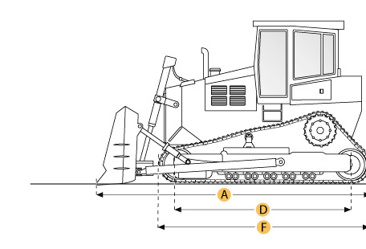
Selected Dimensions
Dimensions
A. Length w/ Blade | 24.8 ft in | 7566 mm
B. Width Over Tracks | 12 ft in | 3647 mm
C. Height to Top of Cab | 14.9 ft in | 4535 mm
D. Length of Track on Ground | 12.8 ft in | 3911 mm
E. Ground Clearance | 2.3 ft in | 701 mm
F. Length w/o Blade | 19.4 ft in | 5915 mm
Undercarriage
G. Track Gauge | 9.5 ft in | 2896 mm
H. Standard Shoe Size | 28 in | 711 mm

Specification
Engine
Model | D348
Gross Power | 700 hp | 522 kw
Displacement | 1788 cu in | 29.3 L
Operational
Operating Weight | 171674 lb | 77870 kg
Fuel Capacity | 382 gal | 1446 L
Transmission
Type | powershift
Number of Forward Gears | 3
Number of Reverse Gears | 3
Max Speed - Forward | 7.2 mph | 11.6 km/h
Max Speed - Reverse | 8.6 mph | 13.8 km/h
Undercarriage
Ground Pressure | 19.9 psi | 137.2 kPa
Ground Contact Area | 8618 in2 | 5.6 m2
Standard Shoe Size | 28 in | 711 mm
Number of Track Rollers per Side | 8
Track Gauge | 9.5 ft in | 2896 mm
Standard Blade
Width | 11.4 ft in | 3480 mm
Dimensions
Length w/o Blade | 19.4 ft in | 5915 mm
Length w/ Blade | 24.8 ft in | 7566 mm
Width Over Tracks | 12 ft in | 3647 mm
Height to Top of Cab | 14.9 ft in | 4535 mm
Length of Track on Ground | 12.8 ft in | 3911 mm
Ground Clearance | 2.3 ft in | 701 mm

