CATERPILLAR 657g Motor Scraper
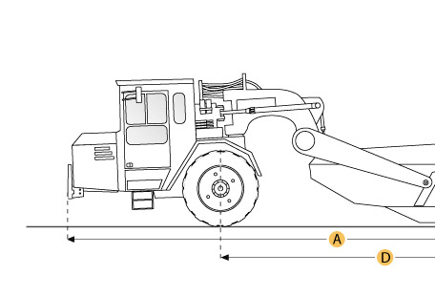

Selected Dimensions
Dimensions
A. Overall Length | 53 ft in | 16164 mm
B. Overall Width | 14.3 ft in | 4344 mm
C. Overall Height | 15.5 ft in | 4710 mm
D. Wheelbase | 32.7 ft in | 9956 mm
E. Tractor Ground Clearance | 2.1 ft in | 645 mm
F. Height to Top of Cab | 12.2 ft in | 3712 mm

Specification
Tractor Engine
Make | Caterpillar
Model | C18 ACERT
Gross Power | 632 hp | 471 kw
Net Power | 600 hp | 447 kw
Displacement | 1105 cu in | 18.1 L
Scraper Engine
Make | Caterpillar
Model | C15 ACERT
Gross Power | 478 hp | 356 kw
Net Power | 451 hp | 337 kw
Displacement | 928 cu in | 15.2 L
Operational
Fuel Capacity | 421.9 gal | 1597 L
Cooling System Fluid Capacity | 56.3 gal | 213 L
Engine Oil Fluid Capacity | 26.9 gal | 102 L
Transmission Fluid Capacity | 68 gal | 257 L
Differential Fluid Capacity | 79.5 gal | 301 L
Hydraulic System Fluid Capacity | 80 gal | 303 L
Wheel Coolant Fluid Capacity - each | 68.6 gal | 260 L
Operating Voltage | 24 V
Alternator Supplied Amperage | 75 amps
Tire Size | 40.5/75 R39
Transmission
Type | 8-speed automatic powershift with electronic control
Number of Forward Gears | 8
Number of Reverse Gears | 1
Max Speed Forward | 36 mph | 55.7 km/h
Max Speed Reverse | 6 mph | 9.7 km/h
Weights
Total Operating - empty | 149417 lb | 67774 kg
Front Axel - empty | 89650 lb | 40665 kg
Rear Axel - empty | 59767 lb | 27110 kg
Total Operating - Loaded | 253420 lb | 114949 kg
Front Axel - loaded | 129244 lb | 58624 kg
Rear Axel - loaded | 124176 lb | 56325 kg
Bowl
Rated Payload | 104058 lb | 47200 kg
Heaped Capactiy | 44 yd3 | 33.6 m3
Struck Capacity | 32 yd3 | 24.5 m3
Max Depth of Cut | 16.7 in | 425 mm
Width of Cut | 12.5 ft in | 3846 mm
Dimensions
Overall Length | 53 ft in | 16164 mm
Overall Width | 14.3 ft in | 4344 mm
Height to Top of Cab | 12.2 ft in | 3712 mm
Overall Height | 15.5 ft in | 4710 mm
Wheelbase | 32.7 ft in | 9956 mm
Tractor Ground Clearance | 2.1 ft in | 645 mm

