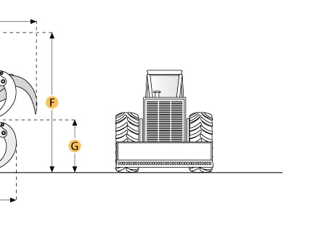
Caterpillar 528 Skidder

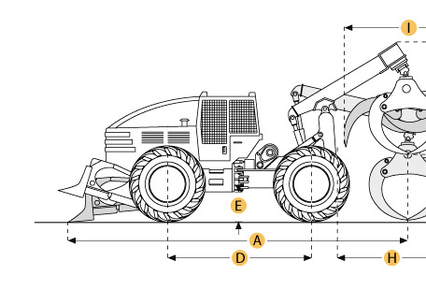
Dimensions
Dimensions
A. Overall Length | 22.7 ft in | 6930 mm
B. Overall Width | 9.6 ft in | 2920 mm
C. Height to Top of Cab | 9.6 ft in | 2920 mm
D. Wheelbase | 10.7 ft in | 3250 mm
E. Ground Clearance | 2 ft in | 610 mm
H. Reach of Grapple at Ground Level | 9.8 ft in | 2972 mm
I. Tong Opening at Tips | 8.7 ft in | 2642 mm

Specification
Engine
Make | Caterpillar
Model | 3306
Gross Power | 174.3 hp | 130 kw
Displacement | 640.7 cu in | 10.5 L
Operational
Operating Weight | 30950.7 lb | 14039 kg
Fuel Capacity | 54.9 gal | 208 L
Hydraulic System Fluid Capacity | 11.9 gal | 45 L
Axle Oscillation | 14 degrees
Tire Size | 24.5-32
Transmission
Number of Forward Gears | 3
Number of Reverse Gears | 3
Max Speed - Forward | 18.7 mph | 30.1 km/h
Max Speed - Reverse | 22.8 mph | 36.7 km/h
Dimensions
Overall Width | 9.6 ft in | 2920 mm
Blade Width | 7.5 ft in | 2290 mm
Height to Top of Cab | 9.6 ft in | 2920 mm
Wheelbase | 10.7 ft in | 3250 mm
Ground Clearance | 2 ft in | 610 mm
Overall Length | 22.7 ft in | 6930 mm
Reach of Grapple at Ground Level | 9.8 ft in | 2972 mm
Tong Opening at Tips | 8.7 ft in | 2642 mm
Grapple Capacity - tongs tip to tip | 12.9 ft2 | 1.2 m2
Drum Diameter | 10 in | 255 mm
Cable Width | 0.75 in | 19 mm
Drum Capacity at Cable Width | 173.9 ft in | 53 m
Max Line Pull - bare drum | 38189 lb | 169.9 kN
Max Line Speed | 229.7 ft/min | 70 m/min

