CATERPILLAR 966f Wheel Loader
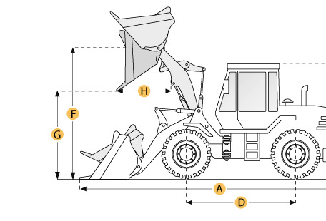

Selected Dimensions
Bucket
G. Dump Clearance at Max Raise | 9.3 ft in | 2845 mm
Dimensions
A. Length with Bucket on Ground | 27.4 ft in | 8366 mm
B. Width Over Tires | 9.6 ft in | 2935 mm
C. Height to Top of Cab | 11.8 ft in | 3585 mm
D. Wheelbase | 11 ft in | 3350 mm
E. Ground Clearance | 1.6 ft in | 476 mm
F. Hinge Pin - Max Height | 13.5 ft in | 4118 mm
H. Reach at Max Lift and Dump | 4.6 ft in | 1398 mm

Specification
Engine
Make | Caterpillar
Model | 3306
Net Power | 220 hp | 164.1 kw
Gross Power | 235 hp | 175.2 kw
Power Measured @ | 2200 rpm
Displacement | 640.7 cu in | 10.5 L
Number of Cylinders | 6
Aspiration | Turbocharged
Operational
Operating Weight | 45161.7 lb | 20485 kg
Fuel Capacity | 80.3 gal | 304 L
Hydrauilc System Fluid Capacity | 54.2 gal | 205 L
Engine Oil Fluid Capacity | 7.4 gal | 28 L
Cooling System Fluid Capacity | 10.8 gal | 41 L
Transmission Fluid Capacity | 15.6 gal | 59 L
Front Axle/Diff Fluid Capacity | 12.4 gal | 47 L
Rear Axle/Diff Fluid Capacity | 12.4 gal | 47 L
Static Tipping Weight | 30825 lb | 13982 kg
Turning Radius | 22.2 ft in | 6779 mm
Operating Voltage | 24 V
Alternator Supplied Amperage | 50 amps
Rear Axle Oscillation | 26 degrees
Tire Size | 26.5-25 14PR
Transmission
Type | Planetary powershift
Number of Forward Gears | 4
Number of Reverse Gears | 4
Max Speed - Forward | 23.4 mph | 37.6 km/h
Max Speed - Reverse | 26.5 mph | 42.6 km/h
Hydraulic System
Relief Valve Pressure | 3000 psi | 20684.3 kPa
Pump Flow Capacity | 79.8 gal/min | 302 L/min
Raise Time | 7.1 sec
Dump Time | 2 sec
Lower Time | 2.4 sec
Bucket
Breakout Force | 48446 lb | 215.5 kN
Dump Clearance at Max Raise | 9.3 ft in | 2845 mm
Bucket Width | 10.2 ft in | 3107 mm
Bucket Capacity - heaped | 4.7 yd3 | 3.6 m3
Bucket Capacity - struck | 4 yd3 | 3.1 m3
Dimensions
Length with Bucket on Ground | 27.4 ft in | 8366 mm
Width Over Tires | 9.6 ft in | 2935 mm
Height to Top of Cab | 11.8 ft in | 3585 mm
Ground Clearance | 1.6 ft in | 476 mm
Wheelbase | 11 ft in | 3350 mm
Hinge Pin - Max Height | 13.5 ft in | 4118 mm
Reach at Max Lift and Dump | 4.6 ft in | 1398 mm

