CATERPILLAR 545 Skidder
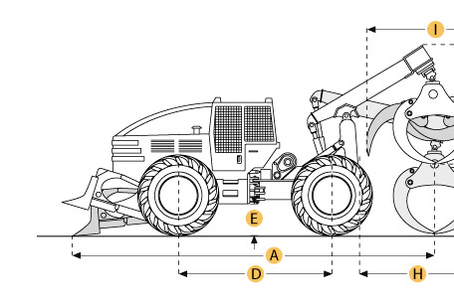

Selected Dimensions
Dimensions
A. Overall Length | 26.1 ft in | 7947.9 mm
B. Overall Width | 11.3 ft in | 3432 mm
C. Height to Top of Cab | 11 ft in | 3366.4 mm
D. Wheelbase | 12.6 ft in | 3838.1 mm
E. Ground Clearance | 2 ft in | 605.5 mm
I. Tong Opening at Tips | 10.8 ft in | 3277 mm

Specification
Engine
Make | Caterpillar
Model | 3306 DITA Engine
Gross Power | 225 hp | 167.8 kw
Net Power | 200 hp | 149.1 kw
Displacement | 640.7 cu in | 10.5 L
Operational
Operating Weight | 40161.6 lb | 18217 kg
Fuel Capacity | 99.9 gal | 378 L
Cooling System Fluid Capacity | 14.8 gal | 56 L
Engine Oil Capacity | 7.7 gal | 29 L
Front Diff Fluid Capacity | 13.7 gal | 52 L
Rear Diff Fluid Capacity | 19.5 gal | 74 L
Transmission Fluid Capacity | 14.3 gal | 54 L
Hydraulic System Fluid Capacity | 32.5 gal | 123 L
Operational Voltage | 24 V
Alternator Supplied Amperage | 75 amps
Tire Size | 30.5 x 32 16 PR
Transmission
Type | Counter-Shaft Powershift
Number of Forward Gears | 5
Number of Reverse Gears | 3
Max Speed - Forward | 17.1 mph | 27.5 km/h
Max Speed - Reverse | 11.6 mph | 18.6 km/h
Hydraulic
Pump Type | Axial Piston
Dimensions
Overall Width | 11.3 ft in | 3432 mm
Blade Width | 10.3 ft in | 3138 mm
Height to Top of Cab | 11 ft in | 3366.4 mm
Max Blade Height | 82.2 in | 2088.2 mm
Wheelbase | 12.6 ft in | 3838.1 mm
Ground Clearance | 2 ft in | 605.5 mm
Overall Length | 26.1 ft in | 7947.9 mm
Tong Opening at Tips | 10.8 ft in | 3277 mm
Grapple Capacity - tongs tip to tip | 16.1 ft2 | 1.5 m2
Tong Opening at Tips | 10.8 ft in | 3277 mm
Drum Diameter | 10 in | 254 mm
Cable Width | 11 in | 279.4 mm
Drum Capacity at Cable Width | 147.6 ft in | 45 m
Max Line Pull - bare drum | 45186.6 lb | 201 kN
Max Line Speed | 360.9 ft/min | 110 m/min

