Find a Caterpillar 518 Grapple Skidder
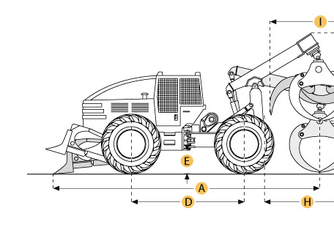

Selected Dimensions
Dimensions
A. Overall Length | 18.2 ft in | 5560 mm
B. Overall Width | 8.7 ft in | 2640 mm
C. Height to Top of Cab | 9.5 ft in | 2910 mm
D. Wheelbase | 10.7 ft in | 3250 mm
E. Ground Clearance | 1.5 ft in | 470 mm
H. Reach of Grapple at Ground Level | 8.6 ft in | 2616 mm
I. Tong Opening at Tips | 6.8 ft in | 2083 mm

Specification
Engine
Make | Caterpillar
Model | 3304
Gross Power | 130 hp | 96.9 kw
Displacement | 427.2 cu in | 7 L
Operational
Operating Weight | 26510.6 lb | 12025 kg
Fuel Capacity | 51 gal | 193 L
Hydraulic System Fluid Capacity | 7.7 gal | 29 L
Axle Oscillation | 14 degrees
Tire Size | 23.1-26
Transmission
Number of Forward Gears | 3
Number of Reverse Gears | 3
Max Speed - Forward | 14.9 mph | 24 km/h
Max Speed - Reverse | 17.8 mph | 28.7 km/h
Dimensions
Overall Width | 8.7 ft in | 2640 mm
Blade Width | 7.1 ft in | 2160 mm
Height to Top of Cab | 9.5 ft in | 2910 mm
Wheelbase | 10.7 ft in | 3250 mm
Ground Clearance | 1.5 ft in | 470 mm
Overall Length | 18.2 ft in | 5560 mm
Reach of Grapple at Ground Level | 8.6 ft in | 2616 mm
Tong Opening at Tips | 6.8 ft in | 2083 mm
Grapple Capacity - tongs tip to tip | 7.5 ft2 | 0.7 m2
Drum Diameter | 10 in | 255 mm
Cable Width | 0.63 in | 16 mm
Drum Capacity at Cable Width | 249.3 ft in | 76 m
Max Line Pull - bare drum | 26363 lb | 117.3 kN
Max Line Speed | 301.8 ft/min | 92 m/min

