Find a Eco Log 580B Harvester being sold at Ritchie Bros. auctions.
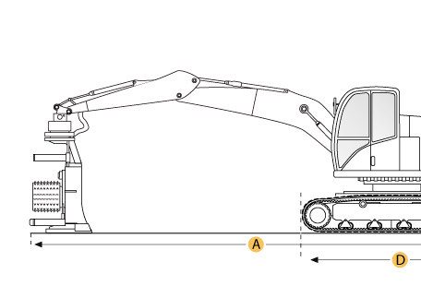

Selected Dimensions
Boom
H. Max Reach w/ Head | 37.1 ft in | 11300 mm
Dimensions
A. Shipping Length - non tilt | 24 ft in | 7300 mm
B. Overall Width | 9.8 ft in | 2990 mm
C. Height to Top of Cab | 15.6 ft in | 4760 mm
D. Wheelbase | 13 ft in | 3960 mm

Specification
Engine
Make | Caterpillar
Model | 3126B
Net Power | 225 hp | 167.8 kw
Displacement | 439.4 cu in | 7.2 L
Max Torque | 848.2 lb ft | 1150 Nm
Operational
Operating Weight | 39352.5 lb | 17850 kg
Fuel Capacity | 105.7 gal | 400 L
Operating Voltage | 24 V
Alternator Supplied Amperage | 150 amps
Max Speed | 11.2 mph | 18 km/h
Transmission Type | hydrostatic 6 wheel drive
DRIVE SYSTEM
Number of Axels | 3
Tire Size - front | 600/55x26.5
Tire Size - rear | 710/55x34
Drive Configuration | 6 wheeldrive
Boom
Max Reach w/ Head | 37.1 ft in | 11300 mm
Dimensions
Forward Tilt | 15 degrees
Side Tilt | 25 degrees
Shipping Length - non tilt | 24 ft in | 7300 mm
Height to Top of Cab | 15.6 ft in | 4760 mm
Overall Width | 9.8 ft in | 2990 mm
Wheelbase | 13 ft in | 3960 mm

