KATO nk800 Hydraulic Truck Crane
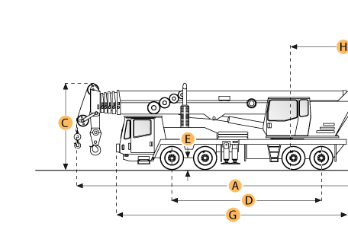
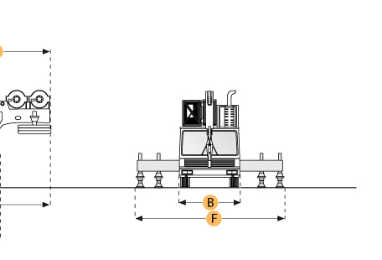

Selected Dimensions
Boom
I. Min Height @ Max Raise Angle | 49.2 ft in | 15 m
J. Max Height @ Max Raise Angle - no jib | 154.2 ft in | 47 m
K. Min Working Radius | 8.2 ft in | 2.5 m
L. Max Working Radius | 101.7 ft in | 31 m
M. Max Elevating Angle | 82 degrees
Dimensions
A. Transport Length | 50.5 ft in | 15400 mm
B. Transport Width | 9.8 ft in | 3000 mm
C. Transport Height | 12.5 ft in | 3800 mm
F. Width w/ Outriggers Extended | 24.9 ft in | 7600 mm
H. Upper Structure Tail Swing Radius | 13.9 ft in | 4250 mm

Specification
UPPER STRUCTURE ENGINE
Make | Mitsubishi
Model | 8DC8
Gross Power | 197.1 hp | 147 kw
Power Measured @ | 2000 rpm
Max Torque | 578.2 lb ft | 784 Nm
Torque Measured @ | 1400 rpm
Displacement | 908.5 cu in | 14.9 L
CARRIER ENGINE
Make | Mitsubishi
Model | 8DC9-1A
Gross Power | 315.1 hp | 235 kw
Power Measured @ | 2200 rpm
Max Torque | 795.1 lb ft | 1078 Nm
Torque Measured @ | 1400 rpm
Displacement | 978.3 cu in | 16 L
Operational
Operating Weight | 132497.8 lb | 60100 kg
Carrier Fuel Capacity | 79.3 gal | 300 L
Operating Voltage | 24 V
Tire Size | 14.00-20-18PR
Transmission
Number of Forward Gears | 9
Number of Reverse Gears | 2
Max Speed - Forward | 34.2 mph | 55 km/h
Boom
Number of Sections | 5
Min Height @ Max Raise Angle | 49.2 ft in | 15 m
Max Height @ Max Raise Angle - no jib | 154.2 ft in | 47 m
Max Elevating Angle | 82 degrees
Max Lift Capacity | 176369.8 lb | 80000 kg
Min Working Radius | 8.2 ft in | 2.5 m
Max Working Radius | 101.7 ft in | 31 m
Swing Speed | 1.6 rpm
Dimensions
Transport Length | 50.5 ft in | 15400 mm
Transport Width | 9.8 ft in | 3000 mm
Transport Height | 12.5 ft in | 3800 mm
Width w/ Outriggers Extended | 24.9 ft in | 7600 mm
Upper Structure Tail Swing Radius | 13.9 ft in | 4250 mm

