Cat D4D Build details
Serial Number group | Build Locality | Date Produced from to | Notes
7R 1045 | France | 1970 - 1977
18J 371 | France | 1966 - 1968
20J 557 | USA | 1967 - 1968
22C 655 | USA | 1967 - 1968
44H 1703 | France | 1970 - 1978
47H 811 | Japan | 1971 - 1978
49J 769 | Australia | 1969 - 1973
58J 603 | France | 1968 - 1969
59J 2725 | France | 1969 - 1978
60J 6008 | France | 1968 - 1978
61J 928 | France | 1968 - 1978
65J 2112 | France | 1969 - 1978
66J 4255 | Japan | 1968 - 1978
67A 1575 | Japan | 1966 - 1969
69K 480 | Australia | 1969 - 1972
74U 1203 | Brazil | 1976 - 1979
78A 7845 | USA | 1963 - 1968
82J 4864 | USA | 1968 - 1977
83J 4169 | USA | 1968 - 1977
84J 2521 | USA | 1968 - 1978
85A 1043 | Australia | 1963 - 1969
86A 3589 | France | 1964 - 1968
88A 1124 | England | 1964 - 1968
91A 1149 | Japan | 1966 - 1969
97F 4446 | Brazil | 1970 - 1979

Caterpillar D4D Crawler Tractor

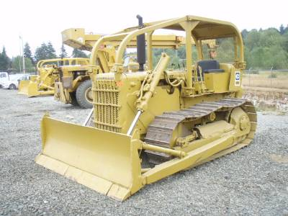
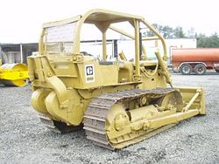

The Caterpillar D4D crawler tractor was introduced in 1963 in the USA, Australia and France. Production began in England in 1964, Japan in 1965, and Brazil in 1969.

Features
The D4D has a D330 four-cylinder engine producing 65 flywheel horsepower (FWHP). However, there are three units with D315 engines and one with a 3304 engine. The D4D comes standard with either an electric starter or an oil clutch.

Configurations
It is available in two configurations: the standard model has a track gauge of 60 inches (152 cm); the Low Ground Pressure (LGP) configuration has a 70-inch (178-cm) track gauge. Both configurations are available with direct drive or powershift transmission.
Standard configuration direct drive tractors were manufactured in the USA, with a 20J, 78A, 82J, or 84J serial number prefix; in Australia, with a 49J or 85A prefix; in France, with 44H, 60J, or 86A prefix; in England, with a 88A prefix; in Japan, with a 65J or 91A prefix; and in Brazil, with a 97F prefix. The 91A and 88A have D315 engines.
Standard configuration powershift tractors were manufactured in the USA, with a 22C, or 83J prefix; in Australia, with a 69K prefix; in Japan with a 47H prefix; in France, with a 58J or 59J prefix; and in Brazil, with a 74U prefix. The 74U has a 3304 engine producing 75 FWHP.
LGP configuration direct drive tractors were manufactured in France, with a 07R prefix, and in Japan, with a 67A prefix.
LGP configuration powershift tractors were manufactured in France, with an 18J or 61J prefix, and in Japan with a 66J prefix.

Modifications
Production of 78A and 58J ended in 1967.
Production of 20J, 22C, 85A, 86A, 88A, and 91A ended in 1968.
Production of 18J and 67A ended in 1969.
Between 1969 and 1972, Caterpillar increased the horsepower of many of the D4D units to 75 FWHP, beginning with 66J01942, 47H00398, 82J03260, 83J01822, 07R00434, 59J01103, 60J03062, 61J00479, and 97F01052.
Production in Australia ended in 1973.
In 1973 and 1974, Caterpillar installed a sleeve metering fuel system, beginning with 47H00555, 82J03651, 83J02566, 84J01613, 07R00724, 44H01122, 59J01766, 60J04066, 61J00642, 65J01591, 66J03008, 74U00480, and 97F01822.
In 1977, Caterpillar installed an interim scroll fuel system into the two remaining Japanese units, beginning with 65J02043 and 66J04017.
Production ended in France, Japan, and the USA in 1977, and in Brazil in 1978.
The Caterpillar D4D was replaced by the Caterpillar D4E.
Based on data from the sales database of Ritchie Bros. Auctioneers, it is estimated that more than 46,800 Caterpillar D4D crawler tractors have been produced.

