Caterpillar D5 Crawler Tractor

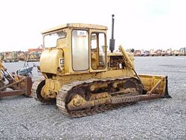
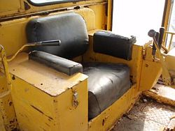
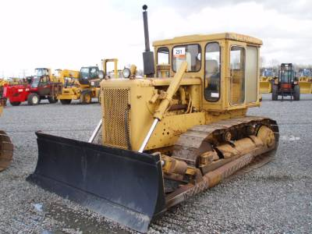

The Caterpillar D5 crawler tractor was introduced in 1967 in the USA and Japan. Production in Australia began in 1968 and in France in 1969. The D5 replaced the D6B series tractor.

Features
The D5 has a D333 or D333C six-cylinder engine producing 93 flywheel horsepower (FWHP). It comes standard with a direct electric start.

Configurations
It is available in two main configurations: the standard model has a track gauge of 74 inches (188 cm); the Low Ground Pressure (LGP) configuration has an 81-inch (206-cm) track gauge. Both are available with either direct drive or powershift transmission.
However, Caterpillar also manufactured four tractors with 60-inch (152-cm) track gauges in the USA only. They are also available with direct drive or powershift transmission.
Standard configuration, direct drive tractors were manufactured in the USA, with a 21J, 82H, 94J, and 98J serial number prefix; in Japan, with a 37J or 67J prefix; in Australia, with a 50J and 51H prefix; and in France, with a 62J prefix. The 21J, 82H, and 37J units have D333 engines; 94J, 98J, 50J, 62J, and 67J have D333C engines. The 21J and 98J units are special application tractors with close-ratio transmission and 90 FWHP.
Standard configuration powershift tractors were manufactured in the USA, with an 84H and 96J prefix; in Japan, with a 97J prefix; in Australia, with a 52H and 54J prefix; and in France, with a 63J prefix. The 84H has a D333 engine, the 54J has a D330C engine; 97J, 96J, 63J have D333C engines.
LGP configuration direct drive tractors were manufactured in Japan, with a 98A or 68J prefix, and in France, with a 12R prefix. All units have D333 engines.
LGP configuration powershift tractors were manufactured in France only, with a 06R prefix.
Sixty-inch (152-cm) track gauge tractors with direct drive transmission have an 81H or 93J prefix. The 81H has a D333 engine; the 93J has a D333C engine.
Sixty-inch (152-cm) track gauge tractors with powershift transmission have an 83H or 95J prefix. The 83H has a D333 engine; the 95J has a D333C engine.

Modifications
Production of 21J, 81H, 82H, 83H, and 84H ended in 1967.
Production of 98A ended in 1968.
Production of 37J and 52H ended in 1969.
Production of 51H ended in 1970.
In 1971 and 1972, Caterpillar increased the horsepower to 105 FWHP on many of the D5 units, beginning with 93J00654, 94J01618, 95J00299, 96J02655, 67J00725, 68J01607, 97J00359, 06R00479, 12R00147, 62J00572, and 63J00806.
Between 1971 and 1977, Caterpillar installed a roll over protection system (ROPS), beginning with 93J00677, 94J02205, 95J00309, 96J04511, 98J01346, 67J01092, 68J03841, 97J00616, 06R00708, and 12R00208. At the same time, two Japanese units (68J and 97J) received an interim scroll fuel system; the other Japanese unit received it a year later, beginning with 67J01103.
Production in Australia ended in 1972.
Between 1973 and 1975, a sleeve metering fuel system was added, beginning with 93J00851, 94J02282, 95J00392, 96J04791, 98J01459, 67J00954, 68J02938, 97J00500, 6R00871, 12R00239, 62J00957, and 63J01512.
In 1974, a hydraulic track adjust was made standard in all American D5 tractors, beginning with 93J00864, 94J02346, 95J00404, 96J04978, and 98J01475.
In 1975, all American units received a ROPS canopy, beginning with 93J00969, 94J02590, 95J00443, 96J05608, and 98J01878.
Production in the USA, Japan, and France ended in 1977.
Based on data from the sales database of Ritchie Bros. Auctioneers, it is estimated that more than 28,300 Caterpillar D5 crawler tractors have been produced.

Highest Serial #
Australia
50J | N/A
51H | N/A
52H | 02566
54J | N/A
France
06R | 01076
12R | 00337
62J | 01255
63J | 01905
Japan
37J | N/A
67J | 01049
68J | 03791
97J | 00382
98A | 00521
USA
21J | 00503
81H | 00378
82H | 00730
83H | 00649
84H | 00772
93J | 01035
94J | 02755
95J | 00561
96J | 06136
98J | 01973
Total = 28,374

