CATERPILLAR d8l Crawler Tractor
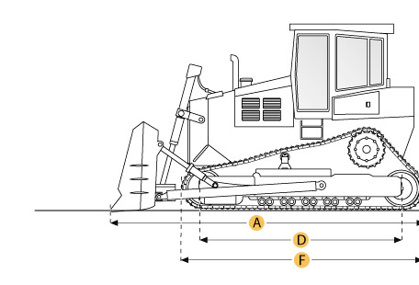

Selected Dimensions

Dimensions
A. Length w/ Blade | 20.4 ft in | 6220 mm
B. Width Over Tracks | 9.3 ft in | 2840 mm
C. Height to Top of Cab | 12.7 ft in | 3870 mm
D. Length of Track on Ground | 10.6 ft in | 3220 mm
E. Ground Clearance | 1.5 ft in | 456 mm
F. Length w/o Blade | 16.2 ft in | 4950 mm
Undercarriage
G. Track Gauge | 7.5 ft in | 2280 mm
H. Standard Shoe Size | 22 in | 560 mm

Specification

Engine
Make | Caterpillar
Model | 3408
Gross Power | 335 hp | 249.8 kw
Displacement | 1098.4 cu in | 18 L
Operational
Operating Weight | 84011.6 lb | 38107 kg
Fuel Capacity | 198.9 gal | 753 L
Transmission
Type | powershift
Number of Forward Gears | 3
Number of Reverse Gears | 3
Max Speed - Forward | 7.4 mph | 11.9 km/h
Max Speed - Reverse | 9.2 mph | 14.8 km/h
Undercarriage
Ground Pressure | 15.1 psi | 103.8 kPa
Ground Contact Area | 5564.5 in2 | 3.6 m2
Standard Shoe Size | 22 in | 560 mm
Number of Track Rollers per Side | 8
Track Gauge | 7.5 ft in | 2280 mm
Standard Blade
Width | 13.7 ft in | 4170 mm
Height | 71 in | 1803 mm
Capacity | 14.4 yd3 | 11 m3
Cutting Depth | 25.9 in | 657 mm
Dimensions
Length w/o Blade | 16.2 ft in | 4950 mm
Length w/ Blade | 20.4 ft in | 6220 mm
Width Over Tracks | 9.3 ft in | 2840 mm
Height to Top of Cab | 12.7 ft in | 3870 mm
Length of Track on Ground | 10.6 ft in | 3220 mm
Ground Clearance | 1.5 ft in | 456 mm

