Komatsu D475A-2 Crawler Tractor
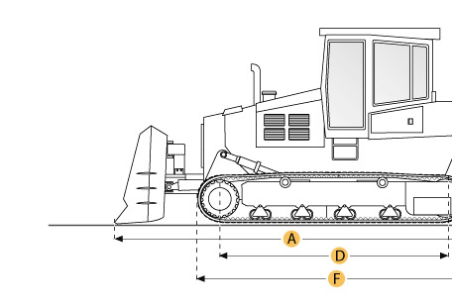

Selected Dimensions
Dimensions
A. Length w/ Blade | 37.8 ft in | 11525 mm
B. Width Over Tracks | 12 ft in | 3645 mm
C. Height to Top of Cab | 14.9 ft in | 4555 mm
D. Length of Track on Ground | 13.7 ft in | 4185 mm
E. Ground Clearance | 2.1 ft in | 655 mm
F. Length w/o Blade | 21.1 ft in | 6420 mm
Undercarriage
G. Track Gauge | 9.1 ft in | 2770 mm
H. Standard Shoe Size | 28 in | 710 mm

Specification
Engine
Make | Komatsu
Model | SA12V140
Gross Power | 781 hp | 582.4 kw
Power Measured @ | 2200 rpm
Displacement | 1860 cu in | 30.5 L
Number of Cylinders | 12
Operational
Operating Weight | 188495.2 lb | 85500 kg
Transmission
Type | TF
Number of Forward Gears | 3
Number of Reverse Gears | 3
Undercarriage
Standard Shoe Size | 28 in | 710 mm
Number of Shoes per Side | 39
Number of Track Rollers per Side | 8
Number of Carrier Rollers per Side | 2
Track Pitch | 12.5 in | 317.5 mm
Track Gauge | 9.1 ft in | 2770 mm
Standard Blade
Width | 17.3 ft in | 5265 mm
Height | 102.8 in | 2610 mm
Dimensions
Length w/o Blade | 21.1 ft in | 6420 mm
Length w/ Blade | 37.8 ft in | 11525 mm
Width Over Tracks | 12 ft in | 3645 mm
Height to Top of Cab | 14.9 ft in | 4555 mm
Length of Track on Ground | 13.7 ft in | 4185 mm
Ground Clearance | 2.1 ft in | 655 mm

