Caterpillar D9H Crawler Tractor
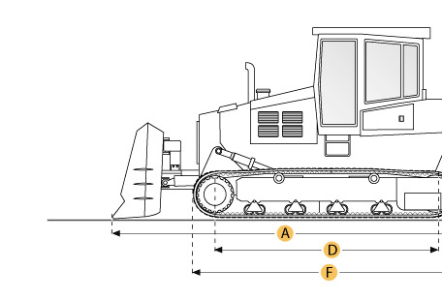

Selected Dimensions
Dimensions
A. Length w/ Blade | 23.8 ft in | 7240 mm
B. Width Over Tracks | 9.9 ft in | 3020 mm
C. Height to Top of Cab | 11.7 ft in | 3560 mm
D. Length of Track on Ground | 11 ft in | 3350 mm
E. Ground Clearance | 1.5 ft in | 460 mm
F. Length w/o Blade | 18.4 ft in | 5610 mm
Undercarriage
G. Track Gauge | 7.5 ft in | 2290 mm
H. Standard Shoe Size | 24 in | 610 mm

Specification
Engine
Model | D353
Gross Power | 410 hp | 305.7 kw
Displacement | 1476.8 cu in | 24.2 L
Operational
Operating Weight | 94313.8 lb | 42780 kg
Fuel Capacity | 229.8 gal | 870 L
Transmission
Type | powershift
Number of Forward Gears | 3
Number of Reverse Gears | 3
Max Speed - Forward | 6.7 mph | 10.8 km/h
Max Speed - Reverse | 8.2 mph | 13.2 km/h
Undercarriage
Ground Pressure | 14.7 psi | 101.4 kPa
Ground Contact Area | 6336 in2 | 4.1 m2
Standard Shoe Size | 24 in | 610 mm
Number of Track Rollers per Side | 7
Track Gauge | 7.5 ft in | 2290 mm
Standard Blade
Width | 14.4 ft in | 4390 mm
Dimensions
Length w/o Blade | 18.4 ft in | 5610 mm
Length w/ Blade | 23.8 ft in | 7240 mm
Width Over Tracks | 9.9 ft in | 3020 mm
Height to Top of Cab | 11.7 ft in | 3560 mm
Length of Track on Ground | 11 ft in | 3350 mm
Ground Clearance | 1.5 ft in | 460 mm

