Caterpillar Japan D6C Серия [26K] Выпуск 73-

ОСНОВНЫЕ ХАРАКТЕРИСТИКИ  Вес голой машины, кг: 11250  Вес с угольным отвалом, кг: N/A  Вес с прямым отвалом, кг: 13850  Вес бульдозера с рыхлителем, кг: NIL  РАЗМЕРЫ  Длина общая, mm (A): NIL  Длина общая, мм (B) :: 4765  Длина общая, мм (C) : 3735  Габаритная ширина, мм (D) : 3210  Габаритная ширина, мм (E) : 2390  Общая высота, мм (F) : 3105  Общая высота, мм (G) : N/A  Ширина колеи, мм (H) : 1880  Длина трака, мм (I) : 2370  Дорожный просвет, мм : 395  Ширина отвала, мм : 3865  Высота отвала, мм : 935  ДВИГАТЕЛЬ  Производитель: CAT  Модель: 3306T(PC)  Мощность, (KW(PS)/rpm) : 104.4(142)/1900  Количество цилиндров : 6  Диаметр поршня, mm : 121x152  Рабочий объем двигателя, л : 10.5 |  | ТРАНСМИССИЯ  Тип: DD  Количество скоростей (перед/зад): 5/4  ХОДОВАЯ ЧАСТЬ  Число звеньев в цепи: 36  Ширина траков, mm: 508  Грунтозоцепная высота, mm: 60.5  Предельный износ, мм: 25  Высота звена, mm: 121.4  Предельный износ, mm: 110.2  Высота шага, mm: 203.2  Предельный износ, mm: 220  Кол-во направляющих роликов/кол-во опорных роликов: 6/2  Диаметр направляющих роликов, mm: 209.6  Предельный износ, mm: 190.5  Диаметр опорных роликов, mm: 187.3  Предельный износ, mm : 168.2  ПРОИЗВОДЕТЕЛЬНОСТЬ  Максимальное тяговое усилие, kN: 143.6  Преодолеваемый подъем: 30

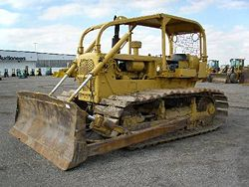
Caterpillar D6C Crawler Tractor

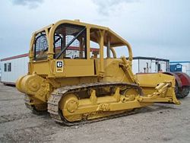
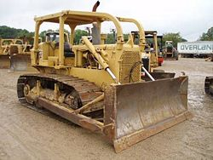
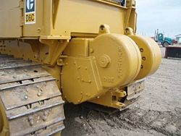
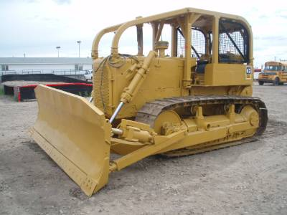
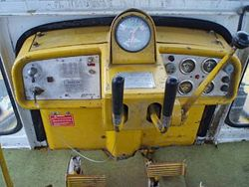

The Caterpillar D6C crawler tractor was introduced in 1963 in the USA and Australia. Production began in Scotland in 1964; in Japan in 1966; and in Brazil in 1971.
The initial D6C units have a D315 six-cylinder engine producing 120 flywheel horsepower (FWHP). It has a 74-inch (188-cm) track gauge and is offered with the choice of direct drive or powershift transmission.
Direct drive tractors were manufactured in the USA, with a 74A prefix, and in Australia with a 71A prefix. Powershift tractors were manufactured in the USA, with 76A prefix, and in Australia with a 73A prefix. The 76A was unique because it came with a turbocharged D333 engine instead of the D315.
In 1964, Caterpillar began installing the D333T engine in all new D6C units. Direct drive tractors were manufactured in Scotland, with an 82A prefix, and in Japan, with a 41A prefix. Powershift units were manufactured in Scotland, with an 83A prefix, and in Japan, with a 96A prefix.

Modifications
Production of the 74A and 76A ended in 1967. Caterpillar released two new units to replace them. Both units have a D333c six-cylinder engine producing 125 FWHP. They were also both equipped with oil-cooled brakes and steering clutches. The direct drive unit was given a 99J prefix; the powershift, a 10K prefix.
Production of the 71A, 73A, 82A, 83A, 41A, and 96A ended in 1968. New units, with D333c engines producing 125 FWHP, were introduced in Scotland and Japan in 1968, Australia in 1969, USA in 1970, and Brazil in 1971 and 1973.
The new direct drive tractors were manufactured in Scotland, with a 46J prefix; in Japan, with a 26K prefix; in Australia, with a 55J prefix; in the USA, with a 17R prefix; and in Brazil, with a 23U prefix. The new powershift tractors were manufactured in Scotland, with 47J prefix; in Japan, with a 69J prefix; in Australia, with a 56J prefix; and in Brazil, with 24U prefix.
In 1971, Caterpillar increased the horsepower of many of the D6C units to 140 FWHP, beginning with 99J01551, 10K05984, 46J00664, 47J01688, 26K00794, 69J01984, and 24U00246.
Also in 1971, Caterpillar began manufacturing a Low Ground Pressure D6C tractor, with an 83-inch (211-cm) track gauge. It was introduced in Japan as a direct drive unit, with a 90B prefix, and in the USA as a turbocharged powershift unit, with a 69U prefix. An LGP powershift unit, with a 3306T engine, began production in Japan in 1975, with a 49W prefix.
Production in Australia (55J and 56J) ended in 1972.
A rollover protection system (ROPS) was added to American units in 1973, beginning with 99J01948, 69U00414, 10K09482, and 17R00642. The ROPS canopy was standardized in American units in 1975, beginning with 99J02556, 69U00619, 10K12049, and 17R01304. ROPS was instituted into Japanese units in 1976, beginning with 26K02038, 90B02085, and 69J04395.
In 1974, a sleeve metering fuel system was added to many units, beginning with 99J02167, 69U00442, 10K10056, 17R00727, 26K01481, 90B01383, 69J02882, and 24U00576.
Most USA production ended in 1976 (69U, 10K, and 17R), but the 99J unit ended in 1977. Production in Scotland (46J and 47J), Japan (26K, 90B, 49W, and 69W), and Brazil (23U and 24U) ended in 1977.
The Caterpillar D6C was replaced by the Caterpillar D6D.
Based on data from the sales database of Ritchie Bros. Auctioneers, it is estimated that more than 47,900 Caterpillar D6C crawler tractors have been produced

Highest Serial #
Australia
55J | N/A
56J | 00451
71A | 00326
73A | 00290
Brazil
23U | N/A
24U | N/A
Japan
26K | 02162
41A | N/A
49W | 00341
69J | 04471
90B | 02938
96A | 00818
Scotland
46J | 01478
47J | 05504
82A | 00759
83A | 00950
USA
10K | 13680
17R | 01141
69U | 00805
74A | 03074
76A | 06057
99J | 02679
Total = 47,924

