Caterpillar D9G гусеничный гидравлический бульдозер с отвалом 9C Cushion для толкания скреперов и задним упором East Peoria США 1961-74 г.
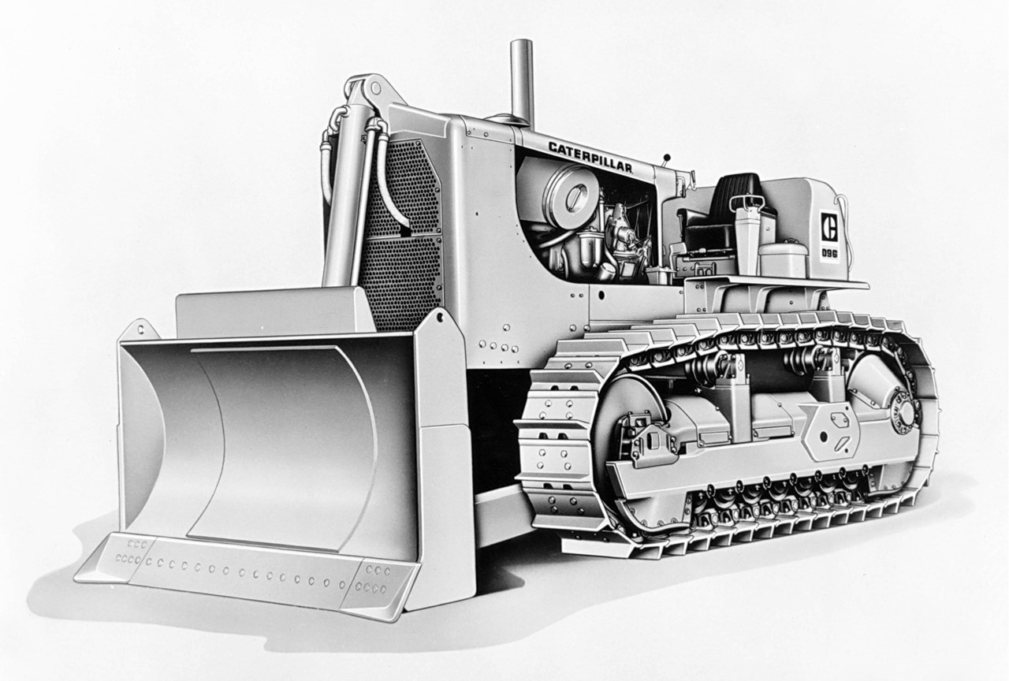

Introduced in 1961 as a replacement for the Cat® D9E, the D9G was the largest dozer produced at the time of it’s introduction. With a wide range of tools and attachments, the D9G was one of the most powerful, productive, and versatile machines in the Caterpillar® lineup. Some of the most notable uses of the D9G were for push-loading scrapers, although it could be equipped with rippers, one of several types of blades available, or configured as a DD9G with Dual D9 Tractors in tandem for use in a wide variety of applications where the full power of two tractors was needed.
Equipped with the 9C Push Blade and Cushion Push Block, this configuration provided flexibility in push-loading situations. Mounted to the main frame, the Cushion Bulldozer features rubber springs behind the blade to absorb on-the-go shock contact.

