Caterpillar 966D Wheel Loader
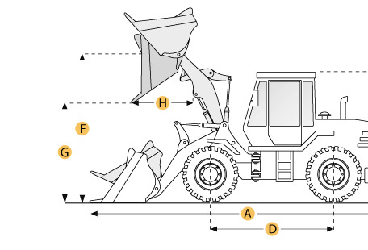

Selected Dimensions
Bucket
G. Dump Clearance at Max Raise | 9.9 ft in | 3018 mm
Dimensions
A. Length with Bucket on Ground | 25.6 ft in | 7814 mm
B. Width Over Tires | 9.4 ft in | 2865 mm
C. Height to Top of Cab | 11.7 ft in | 3560 mm
D. Wheelbase | 11 ft in | 3350 mm
E. Ground Clearance | 1.5 ft in | 451 mm
F. Hinge Pin - Max Height | 1.8 ft in | 560 mm
H. Reach at Max Lift and Dump | 3.6 ft in | 1090 mm

Specification
Engine
Make | Caterpillar
Model | 3306
Net Power | 199.8 hp | 149 kw
Displacement | 640.7 cu in | 10.5 L
Operational
Operating Weight | 43001.2 lb | 19505 kg
Fuel Capacity | 81.4 gal | 308 L
Hydrauilc System Fluid Capacity | 60.8 gal | 230 L
Static Tipping Weight | 30366.5 lb | 13774 kg
Turning Radius | 24 ft in | 7320 mm
Transmission
Number of Forward Gears | 4
Number of Reverse Gears | 4
Max Speed - Forward | 21.3 mph | 34.3 km/h
Max Speed - Reverse | 23.7 mph | 38.1 km/h
Hydraulic System
Raise Time | 6.3 sec
Dump Time | 2 sec
Lower Time | 3 sec
Bucket
Breakout Force | lb | 216 kN
Dump Clearance at Max Raise | 9.9 ft in | 3018 mm
Bucket Width | 10 ft in | 3040 mm
Bucket Capacity - heaped | 4.1 yd3 | 3.1 m3
Bucket Capacity - struck | 3.4 yd3 | 2.6 m3
Dimensions
Length with Bucket on Ground | 25.6 ft in | 7814 mm
Width Over Tires | 9.4 ft in | 2865 mm
Height to Top of Cab | 11.7 ft in | 3560 mm
Ground Clearance | 1.5 ft in | 451 mm
Wheelbase | 11 ft in | 3350 mm
Hinge Pin - Max Height | 1.8 ft in | 560 mm
Reach at Max Lift and Dump | 3.6 ft in | 1090 mm

