Caterpillar 988B Wheel Loader
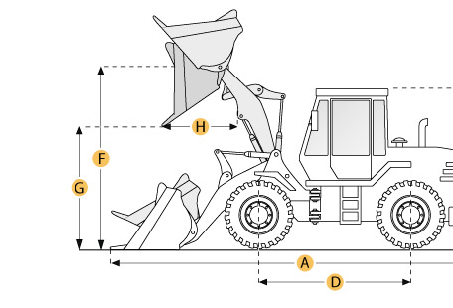

Selected Dimensions
Bucket
G. Dump Clearance at Max Raise | 11.3 ft in | 3450 mm
Dimensions
A. Length with Bucket on Ground | 34.1 ft in | 10390 mm
B. Width Over Tires | 11.5 ft in | 3520 mm
C. Height to Top of Cab | 13.5 ft in | 4115 mm
E. Ground Clearance | 1.6 ft in | 474 mm
H. Reach at Max Lift and Dump | 7.1 ft in | 2150 mm

Specification
Engine
Make | Caterpillar
Model | 3408
Gross Power | 375 hp | 279.6 kw
Displacement | 1098.4 cu in | 18 L
Operational
Operating Weight | 95603.5 lb | 43365 kg
Fuel Capacity | 165.1 gal | 625 L
Hydrauilc System Fluid Capacity | 65 gal | 246 L
Static Tipping Weight | 49493.8 lb | 22450 kg
Transmission
Number of Forward Gears | 4
Number of Reverse Gears | 4
Max Speed - Forward | 22.5 mph | 36.2 km/h
Max Speed - Reverse | 25.7 mph | 41.4 km/h
Hydraulic System
Raise Time | 9.4 sec
Dump Time | 3 sec
Lower Time | 4.5 sec
Bucket
Breakout Force | 80100 lb | 356.3 kN
Dump Clearance at Max Raise | 11.3 ft in | 3450 mm
Bucket Capacity - heaped | 7.1 yd3 | 5.4 m3
Bucket Capacity - struck | 5.9 yd3 | 4.5 m3
Dimensions
Length with Bucket on Ground | 34.1 ft in | 10390 mm
Width Over Tires | 11.5 ft in | 3520 mm
Height to Top of Cab | 13.5 ft in | 4115 mm
Ground Clearance | 1.6 ft in | 474 mm
Reach at Max Lift and Dump | 7.1 ft in | 2150 mm

