Looking to purchase this item?
Find a Caterpillar 983 Crawler Loader being sold at Ritchie Bros. auctions.

Need to sell equipment?
Complete this form and a Ritchie Bros. representative will contact you.
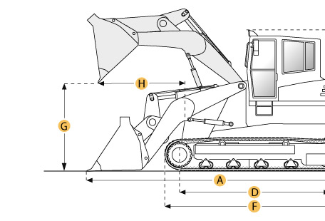

Selected Dimensions
Dimensions
A. Length with Bucket on Ground | 22.2 ft in | 6780 mm
B. Width to Outside of Tracks | 9.5 ft in | 2900 mm
C. Height to Top of Cab | ft in | mm
E. Ground Clearance | 2 ft in | 600 mm
G. Clearance at Full Height and Dump | 12 ft in | 3650 mm
H. Reach at Dump Height | 7.1 ft in | 2160 mm
Undercarriage
I. Track Gauge | 92.1 in | 2340 mm

Specification
Engine
Make | Caterpillar
Model | D343
Net Power | 275 hp | 205.1 kw
Displacement | 890.9 cu in | 14.6 L
Power Measured @ | 2060 rpm
Aspiration | turbocharged
Number of Cylinders | 6
Operational
Operating Weight | 71650.2 lb | 32500 kg
Fuel Capacity | 134.7 gal | 510 L
Cooling System Fluid Capacity | 23 gal | 87 L
Engine Oil Capacity | 10.8 gal | 41 L
Final Drive Fluid Capacity - each | 8.5 gal | 32 L
Hydraulic System Fluid Capacity | 38 gal | 144 L
Static Tipping Load | 48680 lb | 22080.9 kg
Breakout Force - Std Bucket | 43850 lb | 195.1 kN
Bucket Capacity - struck | 3.7 yd3 | 2.9 m3
Bucket Capacity - heaped | 4.8 yd3 | 3.7 m3
Operating Voltage | 24 V
Alternator Supplied Amperage | 19 amps
Max Speed | 7.4 mph | 11.9 km/h
Undercarriage
Track Shoe Width | 22 in | 560 mm
Number of Shoes per Side | 42
Number of Track Rollers per Side | 7
Length of Track on Ground | 11.1 ft in | 3380 mm
Ground Contact Area | 5843.5 in2 | 3.8 m2
Track Gauge | 92.1 in | 2340 mm
Hydraulic
Pump Flow Capacity | 137.4 gal/min | 520 L/min
Relief Valve Pressure | 2150 psi | 14823.7 kPa
Raise Time | 7.7 sec
Dump Time | 1.4 sec
Lower Time | 3.2 sec
Dimensions
Length to Front of Track | 15.2 ft in | 4620 mm
Length with Bucket on Ground | 22.2 ft in | 6780 mm
Width to Outside of Tracks | 9.5 ft in | 2900 mm
Height to Top of Cab | ft in | mm
Ground Clearance | 2 ft in | 600 mm
Clearance at Full Height and Dump | 12 ft in | 3650 mm
Reach at Dump Height | 7.1 ft in | 2160 mm
New & Used Heavy Equipment http://ritchiespecs.com/specification?type=Cons&category=Crawler+Loader&make=Caterpillar&model=983&modelid=93221#ixzz4wFR4M07U

