Caterpillar 953C
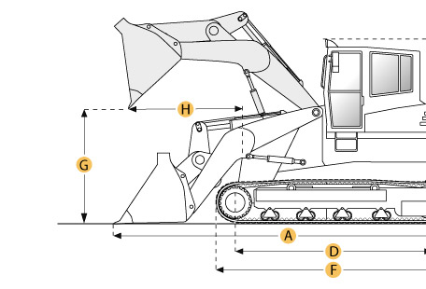

Selected Dimensions
Dimensions
A. Length with Bucket on Ground | 19.3 ft in | 5879 mm
B. Width to Outside of Tracks | 7.5 ft in | 2300 mm
C. Height to Top of Cab | 10.3 ft in | 3150 mm
E. Ground Clearance | 1.2 ft in | 377 mm
G. Clearance at Full Height and Dump | 9.5 ft in | 2903 mm
H. Reach at Dump Height | 3.2 ft in | 974 mm
Undercarriage
I. Track Gauge | 70.9 in | 1800 mm

Specification
Engine
Make | Caterpillar
Model | 3126B ATAAC
Net Power | 128 hp | 95.4 kw
Displacement | 442 cu in | 7.2 L
Power Measured @ | 2000 rpm
Aspiration | Turbocharged
Number of Cylinders | 6
Operational
Operating Weight | 32895.2 lb | 14921 kg
Fuel Capacity | 63.7 gal | 241 L
Cooling System Fluid Capacity | 6.9 gal | 26 L
Engine Oil Capacity | 4.8 gal | 18 L
Final Drive Fluid Capacity - each | 4.1 gal | 15.5 L
Hydraulic System Fluid Capacity | 29.1 gal | 110 L
Static Tipping Load | 23565.2 lb | 10689 kg
Breakout Force - Std Bucket | 21400 lb | 95.2 kN
Bucket Capacity - struck | 1.6 yd3 | 1.3 m3
Bucket Capacity - heaped | 2 yd3 | 1.5 m3
Operating Voltage | 12 V
Alternator Supplied Amperage | 70 amps
Max Speed | 5.7 mph | 9.2 km/h
Undercarriage
Track Shoe Width | 19.7 in | 500 mm
Number of Shoes per Side | 37
Number of Track Rollers per Side | 6
Length of Track on Ground | 7.7 ft in | 2345 mm
Ground Contact Area | 3565 in2 | 2.3 m2
Ground Pressure | 9.5 psi | 65.5 kPa
Track Gauge | 70.9 in | 1800 mm
Hydraulic
Pump Type | VANE
Pump Flow Capacity | 31.7 gal/min | 120 L/min
Relief Valve Pressure | 3481 psi | 24000.6 kPa
Raise Time | 6.9 sec
Dump Time | 1.3 sec
Lower Time | 2.6 sec
Dimensions
Length to Front of Track | 14.3 ft in | 4350 mm
Length with Bucket on Ground | 19.3 ft in | 5879 mm
Width to Outside of Tracks | 7.5 ft in | 2300 mm
Height to Top of Cab | 10.3 ft in | 3150 mm
Ground Clearance | 1.2 ft in | 377 mm
Clearance at Full Height and Dump | 9.5 ft in | 2903 mm
Reach at Dump Height | 3.2 ft in | 974 mm

