Komatsu D155A-1 Crawler Tractor
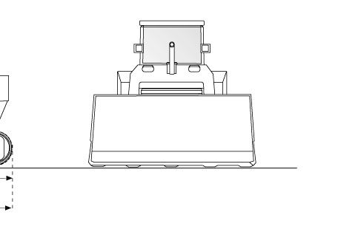
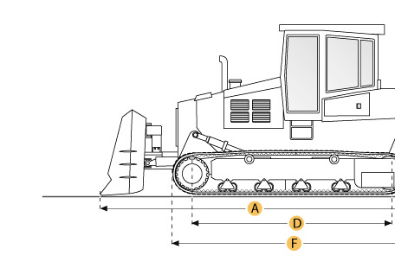

Selected Dimensions
Dimensions
B. Width Over Tracks | 9.2 ft in | 2810 mm
D. Length of Track on Ground | 10.3 ft in | 3150 mm
F. Length w/o Blade | 16.7 ft in | 5100 mm
Undercarriage
G. Track Gauge | 7 ft in | 2140 mm
H. Standard Shoe Size | 22 in | 560 mm

Specification
Engine
Make | Komatsu
Model | S6D155-4
Gross Power | 320 hp | 238.6 kw
Displacement | 1175 cu in | 19.3 L
Aspiration | turbocharged
Operational
Operating Weight | 59350 lb | 26920.7 kg
Fuel Capacity | 158.5 gal | 600 L
Cooling System Fluid Capacity | 43.6 gal | 165 L
Transmission
Type | planetary gear
Number of Forward Gears | 3
Number of Reverse Gears | 3
Max Speed - Forward | 7.3 mph | 11.8 km/h
Max Speed - Reverse | 8.5 mph | 13.7 km/h
Undercarriage
Ground Pressure | 11 psi | 75.5 kPa
Standard Shoe Size | 22 in | 560 mm
Number of Track Rollers per Side | 7
Track Gauge | 7 ft in | 2140 mm
Standard Blade
Width | 13.5 ft in | 4130 mm
Height | 62.6 in | 1590 mm
Capacity | 13.6 yd3 | 10.4 m3
Cutting Depth | 22 in | 560 mm
Dimensions
Length w/o Blade | 16.7 ft in | 5100 mm
Width Over Tracks | 9.2 ft in | 2810 mm
Length of Track on Ground | 10.3 ft in | 3150 mm

