Komatsu D455A-1 Crawler Tractor
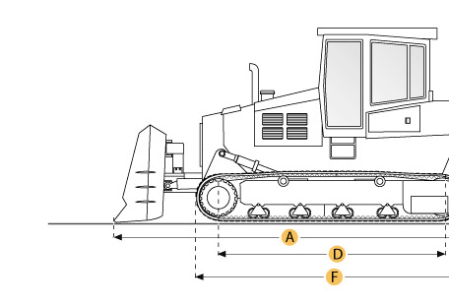

Selected Dimensions
Dimensions
A. Length w/ Blade | 36.5 ft in | 11130 mm
B. Width Over Tracks | 11.4 ft in | 3480 mm
C. Height to Top of Cab | 14.5 ft in | 4430 mm
D. Length of Track on Ground | 12.8 ft in | 3910 mm
E. Ground Clearance | 1.8 ft in | 540 mm
F. Length w/o Blade | 20.4 ft in | 6215 mm
Undercarriage
G. Track Gauge | 8.7 ft in | 2650 mm
H. Standard Shoe Size | 29.9 in | 760 mm

Specification
Engine
Make | Komatsu
Model | VTA1710-C800
Gross Power | 620 hp | 462.3 kw
Power Measured @ | 2000 rpm
Displacement | 1709.9 cu in | 28 L
Aspiration | turbocharged
Number of Cylinders | 12
Operational
Operating Weight | 157630.5 lb | 71500 kg
Fuel Capacity | 338.1 gal | 1280 L
Cooling System Fluid Capacity | 52.8 gal | 200 L
Transmission
Type | TF
Number of Forward Gears | 4
Number of Reverse Gears | 4
Max Speed - Forward | 9.1 mph | 14.6 km/h
Max Speed - Reverse | 8.9 mph | 14.4 km/h
Undercarriage
Ground Pressure | 13.9 psi | 96.1 kPa
Standard Shoe Size | 29.9 in | 760 mm
Number of Shoes per Side | 37
Number of Track Rollers per Side | 7
Number of Carrier Rollers per Side | 2
Track Pitch | 12.5 in | 317.5 mm
Track Gauge | 8.7 ft in | 2650 mm
Standard Blade
Width | 15.7 ft in | 4800 mm
Height | 84.1 in | 2135 mm
Capacity | 34.1 yd3 | 26.1 m3
Cutting Depth | 31.5 in | 800 mm
Dimensions
Length w/o Blade | 20.4 ft in | 6215 mm
Length w/ Blade | 36.5 ft in | 11130 mm
Width Over Tracks | 11.4 ft in | 3480 mm
Height to Top of Cab | 14.5 ft in | 4430 mm
Length of Track on Ground | 12.8 ft in | 3910 mm
Ground Clearance | 1.8 ft in | 540 mm

