CATERPILLAR d11n Crawler Tractor
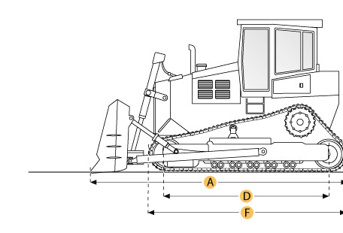

Selected Dimensions
Dimensions
A. Length w/ Blade | 27.5 ft in | 8390 mm
B. Width Over Tracks | 12.4 ft in | 3780 mm
C. Height to Top of Cab | 15 ft in | 4560 mm
D. Length of Track on Ground | 14.6 ft in | 4440 mm
E. Ground Clearance | 2 ft in | 623 mm
F. Length w/o Blade | 20.2 ft in | 6160 mm
Undercarriage
G. Track Gauge | 9.5 ft in | 2890 mm
H. Standard Shoe Size | 28 in | 710 mm

Specification
Engine
Make | Caterpillar
Model | 3508
Gross Power | 770 hp | 574.2 kw
Displacement | 2105.3 cu in | 34.5 L
Aspiration | Turbocharged
Operational
Operating Weight | 211304.3 lb | 95846 kg
Fuel Capacity | 393.6 gal | 1490 L
Hydraulic Fluid Capacity | 44.6 gal | 169 L
Transmission
Type | powershift
Number of Forward Gears | 3
Number of Reverse Gears | 3
Max Speed - Forward | 7.2 mph | 11.6 km/h
Max Speed - Reverse | 8.8 mph | 14.1 km/h
Undercarriage
Ground Pressure | 21.6 psi | 149 kPa
Ground Contact Area | 9796 in2 | 6.3 m2
Standard Shoe Size | 28 in | 710 mm
Number of Track Rollers per Side | 8
Track Gauge | 9.5 ft in | 2890 mm
Hydraulic System
Relief Valve Pressure | 3300 psi | 22752.7 kPa
Pump Flow Capacity | 161.1 gal/min | 610 L/min
Standard Blade
Width | 18.4 ft in | 5600 mm
Height | 90.9 in | 2310 mm
Capacity | 33.5 yd3 | 25.6 m3
Cutting Depth | 30.5 in | 774 mm
Dimensions
Length w/o Blade | 20.2 ft in | 6160 mm
Length w/ Blade | 27.5 ft in | 8390 mm
Width Over Tracks | 12.4 ft in | 3780 mm
Height to Top of Cab | 15 ft in | 4560 mm
Length of Track on Ground | 14.6 ft in | 4440 mm
Ground Clearance | 2 ft in | 623 mm

Caterpillar Japan D11N
Серия [74Z] Выпуск 85-94
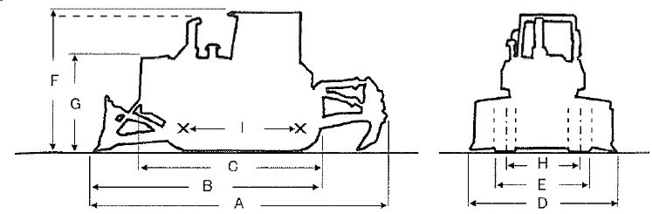
ОСНОВНЫЕ ХАРАКТЕРИСТИКИ  Вес голой машины, кг: 69950  Вес с угольным отвалом, кг: NIL  Вес с прямым отвалом, кг: 0  Вес бульдозера с рыхлителем, кг: 95350(VMR).93250(VSR)  РАЗМЕРЫ  Длина общая, mm (A): 10385(VMR),10725(VSR)  Длина общая, мм (B) :: N/A  Длина общая, мм (C) : 6165  Габаритная ширина, мм (D) : 5645  Габаритная ширина, мм (E) : 3650  Общая высота, мм (F) : 4560  Общая высота, мм (G) : N/A  Ширина колеи, мм (H) : 2895  Длина трака, мм (I) : 4440  Дорожный просвет, мм : 625  Ширина отвала, мм : 5645  Высота отвала, мм : 2305  ДВИГАТЕЛЬ  Производитель: CAT  Модель: 3508  Мощность, (KW(PS)/rpm) : 574.4(781)/1800  Количество цилиндров : 8  Диаметр поршня, mm : 170x190  Рабочий объем двигателя, л : 34.5 | ТРАНСМИССИЯ  Тип: PC.TC  Количество скоростей (перед/зад): 3/3  ХОДОВАЯ ЧАСТЬ  Число звеньев в цепи: 41  Ширина траков, mm: 710  Грунтозоцепная высота, mm: 102  Предельный износ, мм: 38  Высота звена, mm: 198  Предельный износ, mm: 186  Высота шага, mm: 318  Предельный износ, mm: 324  Кол-во направляющих роликов/кол-во опорных роликов: 4/0-6/0  Диаметр направляющих роликов, mm: 277-287  Предельный износ, mm: 218.5  Диаметр опорных роликов, mm: NIL  Предельный износ, mm : NIL  ПРОИЗВОДЕТЕЛЬНОСТЬ  Максимальное тяговое усилие, kN: N/A  Преодолеваемый подъем: N/A | Примечание ROPS/C,VSR=OP

