CATERPILLAR d4e Crawler Tractor
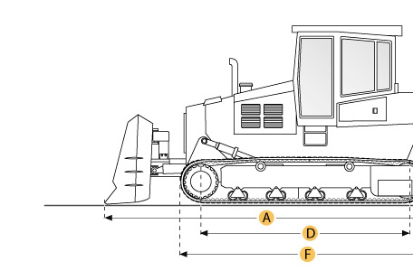

Selected Dimensions
Dimensions
A. Length w/ Blade | 12.7 ft in | 3860 mm
B. Width Over Tracks | 6.5 ft in | 1980 mm
C. Height to Top of Cab | 8.8 ft in | 2690 mm
D. Length of Track on Ground | 6 ft in | 1829 mm
E. Ground Clearance | 1.2 ft in | 356 mm
F. Length w/o Blade | 10.5 ft in | 3200 mm
Undercarriage
G. Track Gauge | 5 ft in | 1520 mm
H. Standard Shoe Size | 13 in | 330 mm

Specification
Engine
Make | Caterpillar
Model | 3304
Gross Power | 75 hp | 55.9 kw
Displacement | 427.2 cu in | 7 L
Aspiration | Naturally
Operational
Operating Weight | 19444.8 lb | 8820 kg
Fuel Capacity | 62.9 gal | 238 L
Transmission
Type | powershift
Number of Forward Gears | 3
Number of Reverse Gears | 3
Max Speed - Forward | 5.8 mph | 9.3 km/h
Max Speed - Reverse | 7.1 mph | 11.4 km/h
Undercarriage
Ground Pressure | 13.3 psi | 91.7 kPa
Ground Contact Area | 1891 in2 | 1.2 m2
Standard Shoe Size | 13 in | 330 mm
Number of Track Rollers per Side | 5
Track Gauge | 5 ft in | 1520 mm
Standard Blade
Width | 8 ft in | 2440 mm
Dimensions
Length w/o Blade | 10.5 ft in | 3200 mm
Length w/ Blade | 12.7 ft in | 3860 mm
Width Over Tracks | 6.5 ft in | 1980 mm
Height to Top of Cab | 8.8 ft in | 2690 mm
Length of Track on Ground | 6 ft in | 1829 mm
Ground Clearance | 1.2 ft in | 356 mm

