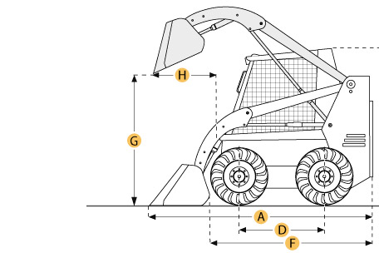

Selected Dimensions
Dimensions
A. Length with Bucket | 12.5 ft in | 3833 mm
B. Width Over Tires | 5.5 ft in | 1676 mm
C. Height to Top of Cab | 6.8 ft in | 2083 mm
D. Wheelbase | 4.5 ft in | 1381 mm
E. Ground Clearance | 8.8 in | 225 mm
F. Length w/o Bucket | 10.7 ft in | 3265 mm
G. Clearance at Max Lift and Dump | 8.2 ft in | 2487 mm
H. Reach at Max Lift and Dump | 30 in | 764 mm

Specification
Engine
Make | Caterpillar
Model | 3044C DIT
Gross Power | 94 hp | 70 kw
Net Power | 90 hp | 67 kw
Power Measured @ | 2500 rpm
Displacement | 201 cu in | 3.3 L
Number of Cylinders | 4
Operational
Operational Weight | 8292 lb | 3761 kg
Fuel Capacity | 26 gal | 98 L
Cooling System Fluid Capacity | 3.7 gal | 14 L
Engine Oil Fluid Capacity | 2.6 gal | 10 L
Hydraulic System Fluid Capacity | 15 gal | 57 L
Chain Box Fluid Capacity - each side | 2.9 gal | 11 L
Max Speed | 7.2 mph | 11.6 km/h
Operating Voltage | 12 V
Alternator Supplied Amperage | 90 amps
Loader
Operating Load Rating | 3250 lb | 1474 kg
Tipping Load | 6500 lb | 2948 kg
Breakout Force | 7315 lb | 3318 kg
Bucket Capacity | 0.52 yd3 | 0.4 m3
Hydraulic
Pump Flow Capacity | 22 gal/min | 84 L/min
Relief Valve Pressure | 3335 psi | 23000 kPa
Dimensions
Length with Bucket | 12.5 ft in | 3833 mm
Length w/o Bucket | 10.7 ft in | 3265 mm
Width Over Tires | 5.5 ft in | 1676 mm
Height to Top of Cab | 6.8 ft in | 2083 mm
Clearance at Max Lift and Dump | 8.2 ft in | 2487 mm
Wheelbase | 4.5 ft in | 1381 mm
Ground Clearance | 8.8 in | 225 mm
Reach at Max Lift and Dump | 30 in | 764 mm
Turning Radius from Center - machine rear | 58.3 in | 1481 mm
Turning Radius from Center - inc bucket | 101.5 in | 2577 mm
New & Used Heavy Equipment http://ritchiespecs.com/specification?category=Skid%20Steer%20Loader&make=CATERPILLAR&model=272c&modelid=92084#ixzz4wFJLkC9l

