Caterpillar 936E Wheel Loader
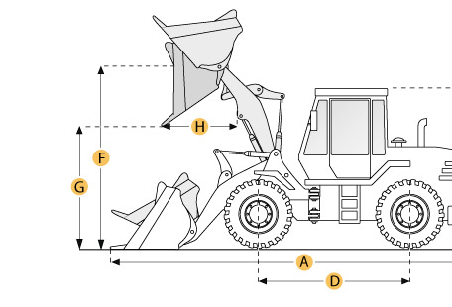

Selected Dimensions
Bucket
G. Dump Clearance at Max Raise | 9.4 ft in | 2879 mm
Dimensions
A. Length with Bucket on Ground | 23.2 ft in | 7060 mm
B. Width Over Tires | 8.4 ft in | 2570 mm
C. Height to Top of Cab | 11.1 ft in | 3370 mm
D. Wheelbase | 9.9 ft in | 3020 mm
E. Ground Clearance | 1.3 ft in | 392 mm
F. Hinge Pin - Max Height | 12.6 ft in | 3840 mm
H. Reach at Max Lift and Dump | 3.2 ft in | 970 mm

Specification
Engine
Make | Caterpillar
Model | 3304
Gross Power | 135.4 hp | 101 kw
Displacement | 427.2 cu in | 7 L
Operational
Operating Weight | 27105.8 lb | 12295 kg
Fuel Capacity | 52.8 gal | 200 L
Hydrauilc System Fluid Capacity | 38.6 gal | 146 L
Static Tipping Weight | 19846 lb | 9002 kg
Turning Radius | 19.5 ft in | 5950 mm
Tire Size | 20.5-25 12PR
Transmission
Number of Forward Gears | 4
Number of Reverse Gears | 4
Max Speed - Forward | 26 mph | 41.8 km/h
Max Speed - Reverse | 28.6 mph | 46 km/h
Hydraulic System
Raise Time | 6.5 sec
Dump Time | 1.8 sec
Lower Time | 3.2 sec
Bucket
Breakout Force | 28032 lb | kN
Dump Clearance at Max Raise | 9.4 ft in | 2879 mm
Bucket Width | 8.7 ft in | 2664 mm
Bucket Capacity - heaped | 2.7 yd3 | 2.1 m3
Bucket Capacity - struck | 2.3 yd3 | 1.8 m3
Dimensions
Length with Bucket on Ground | 23.2 ft in | 7060 mm
Width Over Tires | 8.4 ft in | 2570 mm
Height to Top of Cab | 11.1 ft in | 3370 mm
Ground Clearance | 1.3 ft in | 392 mm
Wheelbase | 9.9 ft in | 3020 mm
Hinge Pin - Max Height | 12.6 ft in | 3840 mm
Reach at Max Lift and Dump | 3.2 ft in | 970 mm

