Case 621D Wheel Loader
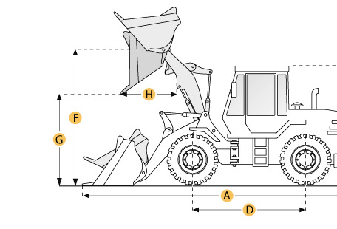

Selected Dimensions
Bucket
G. Dump Clearance at Max Raise | 9.2 ft in | 2806 mm
Dimensions
A. Length with Bucket on Ground | 23.1 ft in | 7036 mm
B. Width Over Tires | 7.8 ft in | 2382 mm
C. Height to Top of Cab | 10.8 ft in | 3306 mm
D. Wheelbase | 9.5 ft in | 2900 mm
E. Ground Clearance | 1.6 ft in | 474 mm
F. Hinge Pin - Max Height | 12.6 ft in | 3835 mm
H. Reach at Max Lift and Dump | 3.3 ft in | 1013 mm

Specification
Engine
Make | Case
Model | Family III 668TA/M2
Net Power | 136 hp | 101.4 kw
Gross Power | 148 hp | 110.4 kw
Power Measured @ | 2000 rpm
Displacement | 409 cu in | 6.7 L
Torque Measured @ | 1200 rpm
Number of Cylinders | 6
Max Torque | 495 lb ft | 671.1 Nm
Torque Rise | 33 %
Aspiration | turbocharged and air to air cooled
Operational
Operating Weight | 26083 lb | 11831 kg
Fuel Capacity | 49.9 gal | 189 L
Hydrauilc System Fluid Capacity | 30 gal | 113.6 L
Engine Oil Fluid Capacity | 4.3 gal | 16.2 L
Cooling System Fluid Capacity | 6.3 gal | 24 L
Transmission Fluid Capacity | 5 gal | 18.9 L
Front Axle/Diff Fluid Capacity | 5.8 gal | 22 L
Rear Axle/Diff Fluid Capacity | 5.8 gal | 22 L
Static Tipping Weight | 22434.2 lb | 10176 kg
Turning Radius | 17 ft in | 5175 mm
Operating Voltage | 24 V
Alternator Supplied Amperage | 70 amps
Rear Axle Oscillation | 24 degrees
Tire Size | 20.5x25 L3
Transmission
Type | 4F/3R proportional w/ electronic control module torque sensing autoshift/manual shift and modulation
Number of Forward Gears | 4
Number of Reverse Gears | 3
Max Speed - Forward | 24 mph | 38.6 km/h
Max Speed - Reverse | 15.6 mph | 25.1 km/h
Hydraulic System
Pump Type | closed centered pressure/flow compensated
Relief Valve Pressure | 3600 psi | 172.4 kPa
Pump Flow Capacity | 45.2 gal/min | 171.1 L/min
Raise Time | 5.4 sec
Dump Time | 1.5 sec
Lower Time | 5 sec
Bucket
Breakout Force | 23237 lb | kN
Dump Clearance at Max Raise | 9.2 ft in | 2806 mm
Bucket Width | 8.5 ft in | 2602 mm
Bucket Capacity - heaped | 3 yd3 | 2.3 m3
Bucket Capacity - struck | 2.6 yd3 | 2 m3
Dimensions
Length with Bucket on Ground | 23.1 ft in | 7036 mm
Width Over Tires | 7.8 ft in | 2382 mm
Height to Top of Cab | 10.8 ft in | 3306 mm
Ground Clearance | 1.6 ft in | 474 mm
Wheelbase | 9.5 ft in | 2900 mm
Hinge Pin - Max Height | 12.6 ft in | 3835 mm
Reach at Max Lift and Dump | 3.3 ft in | 1013 mm

