Komatsu W120-3 Wheel Loader
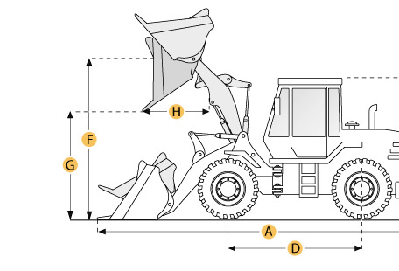

Selected Dimensions
Bucket
G. Dump Clearance at Max Raise | 9.8 ft in | 2995 mm
Dimensions
A. Length with Bucket on Ground | 25.1 ft in | 7640 mm
B. Width Over Tires | 9.1 ft in | 2780 mm
C. Height to Top of Cab | 11.1 ft in | 3375 mm
D. Wheelbase | 10.3 ft in | 3125 mm
E. Ground Clearance | 1.5 ft in | 460 mm
F. Hinge Pin - Max Height | 13.2 ft in | 4030 mm
H. Reach at Max Lift and Dump | 4 ft in | 1230 mm

Specification
Engine
Make | Komatsu
Model | SA6D110
Gross Power | 200 hp | 149.1 kw
Displacement | 435 cu in | 7.1 L
Aspiration | turbocharged
Operational
Operating Weight | 37787.2 lb | 17140 kg
Fuel Capacity | 80 gal | 303 L
Cooling System Fluid Capacity | 12.9 gal | 49 L
Static Tipping Weight | 28990.8 lb | 13150 kg
Turning Radius | 22.7 ft in | 6920 mm
Tire Size | 23.5-25-12PR (L-2)
Transmission
Type | TORQFLOW full power shift countershaft full soft-shift
Number of Forward Gears | 3
Number of Reverse Gears | 3
Max Speed - Forward | 18.6 mph | 30 km/h
Max Speed - Reverse | 20 mph | 32.2 km/h
Hydraulic System
Raise Time | 6.3 sec
Dump Time | 2.3 sec
Lower Time | 3.2 sec
Bucket
Breakout Force | 31530 lb | 140.1 kN
Dump Clearance at Max Raise | 9.8 ft in | 2995 mm
Bucket Width | 9.6 ft in | 2925 mm
Bucket Capacity - heaped | 4.3 yd3 | 3.3 m3
Dimensions
Length with Bucket on Ground | 25.1 ft in | 7640 mm
Width Over Tires | 9.1 ft in | 2780 mm
Height to Top of Cab | 11.1 ft in | 3375 mm
Ground Clearance | 1.5 ft in | 460 mm
Wheelbase | 10.3 ft in | 3125 mm
Hinge Pin - Max Height | 13.2 ft in | 4030 mm
Reach at Max Lift and Dump | 4 ft in | 1230 mm

