KAWASAKI 90z iii Wheel Loader
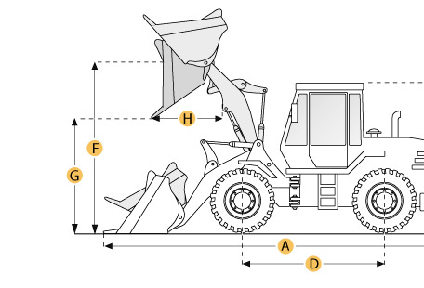

Selected Dimensions
Bucket
G. Dump Clearance at Max Raise | 9.9 ft in | 3020 mm
Dimensions
A. Length with Bucket on Ground | 27.5 ft in | 8370 mm
B. Width Over Tires | 9.6 ft in | 2930 mm
C. Height to Top of Cab | 11.6 ft in | 3530 mm
D. Wheelbase | 11.2 ft in | 3400 mm
E. Ground Clearance | 1.7 ft in | 515 mm
F. Hinge Pin - Max Height | 14 ft in | 4260 mm
H. Reach at Max Lift and Dump | 4.1 ft in | 1240 mm

Specification
Engine
Make | Cummins
Model | LTA-10-C290
Net Power | 256 hp | 190.9 kw
Power Measured @ | 2100 rpm
Displacement | 611 cu in | 10 L
Torque Measured @ | 1300 rpm
Number of Cylinders | 6
Max Torque | 832 lb ft | 1128 Nm
Aspiration | turbocharged & after cooled
Operational
Operating Weight | 47994.6 lb | 21770 kg
Fuel Capacity | 81.9 gal | 310 L
Hydrauilc System Fluid Capacity | 43.6 gal | 165 L
Engine Oil Fluid Capacity | 11.6 gal | 44 L
Cooling System Fluid Capacity | 14.8 gal | 56 L
Transmission Fluid Capacity | 15.9 gal | 60 L
Front Axle/Diff Fluid Capacity | 14.5 gal | 55 L
Rear Axle/Diff Fluid Capacity | 14.5 gal | 55 L
Static Tipping Weight | 35274 lb | 16000 kg
Turning Radius | 22.4 ft in | 6825 mm
Operating Voltage | 24 V
Alternator Supplied Amperage | 75 amps
Rear Axle Oscillation | 24 degrees
Tire Size | 26.5-25-20PR (L-3)
Transmission
Type | full power shift
Number of Forward Gears | 4
Number of Reverse Gears | 4
Max Speed - Forward | 20.5 mph | 33 km/h
Max Speed - Reverse | 20.8 mph | 33.5 km/h
Hydraulic System
Pump Type | gear type
Relief Valve Pressure | 3000 psi | 20684.3 kPa
Pump Flow Capacity | 37 gal/min | 140.1 L/min
Raise Time | 6.1 sec
Dump Time | 1.6 sec
Lower Time | 3 sec
Bucket
Breakout Force | 43870 lb | 195.1 kN
Dump Clearance at Max Raise | 9.9 ft in | 3020 mm
Bucket Width | 10.2 ft in | 3100 mm
Bucket Capacity - heaped | 5 yd3 | 3.8 m3
Bucket Capacity - struck | 4.3 yd3 | 3.3 m3
Dimensions
Length with Bucket on Ground | 27.5 ft in | 8370 mm
Width Over Tires | 9.6 ft in | 2930 mm
Height to Top of Cab | 11.6 ft in | 3530 mm
Ground Clearance | 1.7 ft in | 515 mm
Wheelbase | 11.2 ft in | 3400 mm
Hinge Pin - Max Height | 14 ft in | 4260 mm
Reach at Max Lift and Dump | 4.1 ft in | 1240 mm

