Komatsu WA270PT-3 Active Wheel Loader
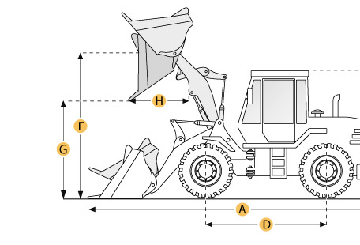

Selected Dimensions
Bucket
G. Dump Clearance at Max Raise | 8.3 ft in | 2525 mm
Dimensions
A. Length with Bucket on Ground | 23.8 ft in | 7250 mm
B. Width Over Tires | 8 ft in | 2440 mm
C. Height to Top of Cab | 10.7 ft in | 3250 mm
D. Wheelbase | 9.5 ft in | 2900 mm
E. Ground Clearance | 1.5 ft in | 460 mm
F. Hinge Pin - Max Height | 12.6 ft in | 3838 mm
H. Reach at Max Lift and Dump | 4.3 ft in | 1324 mm

Specification
Engine
Make | Komatsu
Model | S6D102 E1
Gross Power | 141 hp | 105.1 kw
Power Measured @ | 2200 rpm
Displacement | 360 cu in | 5.9 L
Number of Cylinders | 6
Max Torque | 417.5 lb ft | 566 Nm
Aspiration | Turbocharged
Operational
Operating Weight | 27998.7 lb | 12700 kg
Fuel Capacity | 48.9 gal | 185 L
Hydrauilc System Fluid Capacity | 31.7 gal | 120 L
Engine Oil Fluid Capacity | 4.2 gal | 16 L
Cooling System Fluid Capacity | 14.8 gal | 56 L
Transmission Fluid Capacity | 4.4 gal | 16.7 L
Front Axle/Diff Fluid Capacity | 6.7 gal | 25.5 L
Rear Axle/Diff Fluid Capacity | 6.7 gal | 25.5 L
Static Tipping Weight | 18077.9 lb | 8200 kg
Turning Radius | 17.2 ft in | 5240 mm
Operating Voltage | 24 V
Alternator Supplied Amperage | 50 amps
Rear Axle Oscillation | 24 degrees
Tire Size | 20.5 R 25
Transmission
Type | fully automatic 4-speed full powershift with 'kickdown'
Number of Forward Gears | 4
Number of Reverse Gears | 3
Max Speed - Forward | 25 mph | 40.2 km/h
Max Speed - Reverse | 16.2 mph | 26 km/h
Hydraulic System
Relief Valve Pressure | 3045.8 psi | 21000 kPa
Pump Flow Capacity | 46.2 gal/min | 175 L/min
Raise Time | 5 sec
Dump Time | 1.5 sec
Lower Time | 2.7 sec
Bucket
Breakout Force | 21581.7 lb | 96 kN
Dump Clearance at Max Raise | 8.3 ft in | 2525 mm
Bucket Width | 8.2 ft in | 2500 mm
Bucket Capacity - heaped | 2.6 yd3 | 2 m3
Dimensions
Length with Bucket on Ground | 23.8 ft in | 7250 mm
Width Over Tires | 8 ft in | 2440 mm
Height to Top of Cab | 10.7 ft in | 3250 mm
Ground Clearance | 1.5 ft in | 460 mm
Wheelbase | 9.5 ft in | 2900 mm
Hinge Pin - Max Height | 12.6 ft in | 3838 mm
Reach at Max Lift and Dump | 4.3 ft in | 1324 mm

