KAWASAKI 90z v Wheel Loader
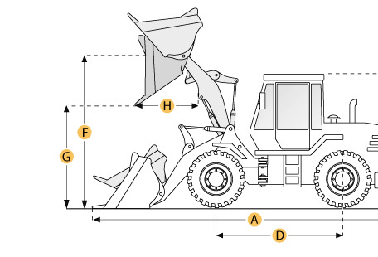

Selected Dimensions
Bucket
G. Dump Clearance at Max Raise | 10.3 ft in | 3130 mm
Dimensions
A. Length with Bucket on Ground | 28.5 ft in | 8700 mm
B. Width Over Tires | 9.6 ft in | 2930 mm
C. Height to Top of Cab | 11.6 ft in | 3535 mm
D. Wheelbase | 11.2 ft in | 3400 mm
E. Ground Clearance | 1.7 ft in | 515 mm
F. Hinge Pin - Max Height | 14.3 ft in | 4360 mm
H. Reach at Max Lift and Dump | 3.9 ft in | 1180 mm

Specification
Engine
Make | Cummins
Model | QSM11
Net Power | 275 hp | 205.1 kw
Power Measured @ | 2100 rpm
Displacement | 660 cu in | 10.8 L
Torque Measured @ | 1400 rpm
Max Torque | 919 lb ft | 1246 Nm
Number of Cylinders | 6
Aspiration | turbocharged & intercooler
Operational
Operating Weight | 51323.6 lb | 23280 kg
Fuel Capacity | 87.2 gal | 330 L
Hydrauilc System Fluid Capacity | 68.7 gal | 260 L
Engine Oil Fluid Capacity | 9 gal | 34 L
Cooling System Fluid Capacity | 15.9 gal | 60 L
Transmission Fluid Capacity | 15.9 gal | 60 L
Front Axle/Diff Fluid Capacity | 19.5 gal | 74 L
Rear Axle/Diff Fluid Capacity | 21.1 gal | 80 L
Static Tipping Weight | 39980.8 lb | 18135 kg
Turning Radius | 22.4 ft in | 6840 mm
Operating Voltage | 24 V
Alternator Supplied Amperage | 75 amps
Rear Axle Oscillation | 24 degrees
Tire Size | 26.5x25-20PR (L-3)
Transmission
Type | full powershift
Number of Forward Gears | 4
Number of Reverse Gears | 4
Max Speed - Forward | 21.1 mph | 34 km/h
Max Speed - Reverse | 21.7 mph | 34.9 km/h
Hydraulic System
Pump Type | gear type
Relief Valve Pressure | 3000 psi | 20684.3 kPa
Pump Flow Capacity | 37.8 gal/min | 143.1 L/min
Raise Time | 6.1 sec
Dump Time | 1.6 sec
Lower Time | 3 sec
Bucket
Breakout Force | 46300 lb | 206 kN
Dump Clearance at Max Raise | 10.3 ft in | 3130 mm
Bucket Width | 10.2 ft in | 3100 mm
Bucket Capacity - heaped | 5.2 yd3 | 4 m3
Bucket Capacity - struck | 4.4 yd3 | 3.4 m3
Dimensions
Length with Bucket on Ground | 28.5 ft in | 8700 mm
Width Over Tires | 9.6 ft in | 2930 mm
Height to Top of Cab | 11.6 ft in | 3535 mm
Ground Clearance | 1.7 ft in | 515 mm
Wheelbase | 11.2 ft in | 3400 mm
Hinge Pin - Max Height | 14.3 ft in | 4360 mm
Reach at Max Lift and Dump | 3.9 ft in | 1180 mm

