CATERPILLAR 955k Crawler Loader
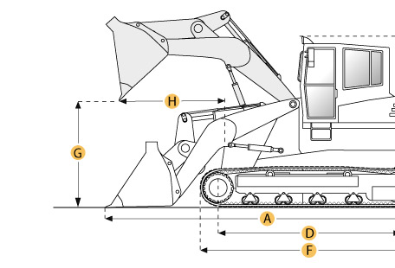

Selected Dimensions
Dimensions
A. Length with Bucket on Ground | 16.4 ft in | 5000 mm
B. Width to Outside of Tracks | 6.8 ft in | 2060 mm
C. Height to Top of Cab | 7.4 ft in | 2260 mm
E. Ground Clearance | 1.3 ft in | 410 mm
G. Clearance at Full Height and Dump | 9.5 ft in | 2900 mm
H. Reach at Dump Height | 5.3 ft in | 1630 mm
Undercarriage
I. Track Gauge | 66.1 in | 1680 mm

Specification
Engine
Make | Caterpillar
Model | D330
Net Power | 115 hp | 85.8 kw
Displacement | 427.2 cu in | 7 L
Power Measured @ | 2185 rpm
Aspiration | turbocharged
Number of Cylinders | 4
Operational
Operating Weight | 28000 lb | 12700.6 kg
Fuel Capacity | 57.1 gal | 216 L
Cooling System Fluid Capacity | 11.1 gal | 42 L
Engine Oil Capacity | 5 gal | 18.9 L
Final Drive Fluid Capacity - each | 2.5 gal | 9.5 L
Hydraulic System Fluid Capacity | 25.9 gal | 98 L
Breakout Force - Std Bucket | lb | kN
Bucket Capacity - struck | 1.5 yd3 | 1.1 m3
Bucket Capacity - heaped | 1.8 yd3 | 1.3 m3
Max Speed | 7 mph | 11.3 km/h
Undercarriage
Track Shoe Width | 15 in | 380 mm
Number of Shoes per Side | 41
Number of Track Rollers per Side | 6
Length of Track on Ground | 7.7 ft in | 2340 mm
Ground Contact Area | 2760 in2 | 1.8 m2
Track Gauge | 66.1 in | 1680 mm
Hydraulic
Raise Time | sec
Dump Time | sec
Lower Time | sec
Dimensions
Length to Front of Track | 11 ft in | 3350 mm
Length with Bucket on Ground | 16.4 ft in | 5000 mm
Width to Outside of Tracks | 6.8 ft in | 2060 mm
Height to Top of Cab | 7.4 ft in | 2260 mm
Ground Clearance | 1.3 ft in | 410 mm
Clearance at Full Height and Dump | 9.5 ft in | 2900 mm
Reach at Dump Height | 5.3 ft in | 1630 mm

