Komatsu WA250PT-5 Integrated Tool Carrier
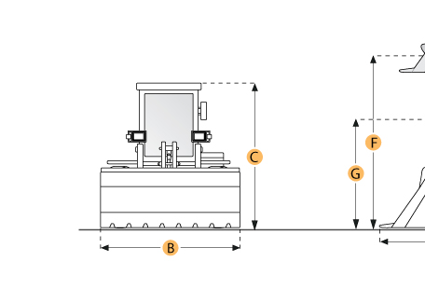

Selected Dimensions
Dimensions
A. Length w/ Bucket on Ground | 24 ft in | 7310 mm
B. Width Over Tires | 8.1 ft in | 2470 mm
C. Height to Top of Cab | 10.7 ft in | 3251 mm
D. Wheelbase | 9.5 ft in | 2900 mm
E. Ground Clearance | 1.5 ft in | 465 mm
G. Dump Clearance at Max Lift | 9.6 ft in | 2905 mm
J. Length w/ Forks on Ground | 26.4 ft in | 8055 mm
K. Max Lift Height | 12.5 ft in | 3620 mm
L. Hook Height at Max Lift - standard | 22.3 ft in | 6770 mm
M. Hook Height at Max Lift - extended | 24.1 ft in | 7345 mm
N. Hook Reach at Max Lift - standard | 9 ft in | 2745 mm
O. Hook Reach at Max Lift - extended | 10.7 ft in | 3245 mm

Specification
Engine
Make | Komatsu
Model | SAA6D102E-2
Gross Power | 139 hp | 104 kw
Net Power | 134 hp | 100 kw
Displacement | 359 cu in | 6 L
Aspiration | turbocharged, air-to-air aftercooled
Operational
Fuel Capacity | 48.6 gal | 184 L
Cooling System Fluid Capacity | 4.6 gal | 17.5 L
Engine Oil Capacity | 5.5 gal | 19.5 L
Front Diff Fluid Capacity | 4.8 gal | 18 L
Rear Diff Fluid Capacity | 4.8 gal | 18 L
Hydraulic System Fluid Capacity | 17.7 gal | 67 L
Turning Radius | 16.3 ft in | 4950 mm
Operating Voltage | 24 V
Alternator Supplied Amperage | 60 amps
Rear Axle Oscillation | 30 degrees
Static Tipping Load - Bucket | 19417 lb | 8800 kg
Static Tipping Load - Forks | 15113 lb | 6855 kg
Static Tipping Load - Material Handler | 26857 lb | 12182 kg
Tire Size | 20.5/25 (L2)
Transmission
Type | Hydrostatic, 1 pump, 2 motors with speed range select
Number of Forward Gears | 4
Number of Reverse Gears | 4
Max Speed Forward | 23.6 mph | 38 km/h
Max Speed Reverse | 23.6 mph | 38 km/h
Hydraulic System
Pump Type | double acting, piston
Relief Valve Pressure | 3000 psi | 20600 kPa
Raise Time | 6.3 sec
Dump Time | 1.7 sec
Lower Time | 3.3 sec
Bucket
Breakout Force | 24581 lb | 109 kN
Bucket Capacity - struck | 2.1 yd3 | 1.6 m3
Dimensions
Width Over Tires | 8.1 ft in | 2470 mm
Height to Top of Cab | 10.7 ft in | 3251 mm
Wheelbase | 9.5 ft in | 2900 mm
Ground Clearance | 1.5 ft in | 465 mm
Length w/ Bucket on Ground | 24 ft in | 7310 mm
Dump Clearance at Max Lift | 9.6 ft in | 2905 mm
Reach at Max Height and Dump | 17 ft in | 5195 mm
Length w/ Forks on Ground | 26.4 ft in | 8055 mm
Max Lift Height | 12.5 ft in | 3620 mm
Hook Height at Max Lift - Standard | 22.3 ft in | 6770 mm
Hook Height at Max Lift - Extended | 24.1 ft in | 7345 mm
Hook Reach at Max Lift - Standard | 9 ft in | 2745 mm
Hook Reach at Max Lift - Extended | 10.7 ft in | 3245 mm

