Liebherr L538 Wheel Loader
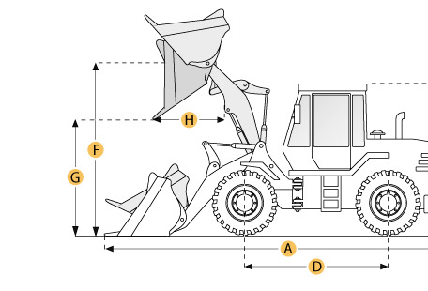

Selected Dimensions
Bucket
G. Dump Clearance at Max Raise | 9.4 ft in | 2870 mm
Dimensions
A. Length with Bucket on Ground | 23.4 ft in | 7135 mm
C. Height to Top of Cab | 10.7 ft in | 3250 mm
D. Wheelbase | 9.5 ft in | 2900 mm
E. Ground Clearance | 1.5 ft in | 460 mm
F. Hinge Pin - Max Height | 12.8 ft in | 3900 mm
H. Reach at Max Lift and Dump | 3.2 ft in | 970 mm

Specification
Engine
Make | Liebherr
Model | D 924 TI-E A1
Gross Power | 136 hp | 101.4 kw
Power Measured @ | 2000 rpm
Displacement | 405.2 cu in | 6.6 L
Torque Measured @ | 1400 rpm
Number of Cylinders | 4
Max Torque | 418.2 lb ft | 567 Nm
Aspiration | Inline engine, water-cooled exhaust-turbo charged with intercooler
Operational
Operating Weight | 27028.7 lb | 12260 kg
Fuel Capacity | 42.3 gal | 160 L
Hydrauilc System Fluid Capacity | 34.3 gal | 130 L
Engine Oil Fluid Capacity | 5.4 gal | 20.5 L
Front Axle/Diff Fluid Capacity | 4.1 gal | 15.5 L
Rear Axle/Diff Fluid Capacity | 4.1 gal | 15.5 L
Static Tipping Weight | 22399 lb | 10160 kg
Turning Radius | 19 ft in | 5795 mm
Operating Voltage | 24 V
Alternator Supplied Amperage | 55 amps
Rear Axle Oscillation | 12 degrees
Tire Size | 20.5 R 25
Transmission
Type | Stepless hydrostatic travel drive
Number of Forward Gears | 2
Number of Reverse Gears | 2
Max Speed - Forward | 21.1 mph | 34 km/h
Max Speed - Reverse | 21.1 mph | 34 km/h
Hydraulic System
Pump Type | Load-Sensing vaiable axial piston pump with output control and pressure cutoff
Relief Valve Pressure | 4351.1 psi | 30000 kPa
Pump Flow Capacity | 37 gal/min | 140 L/min
Raise Time | 6 sec
Dump Time | 1.6 sec
Lower Time | 4 sec
Bucket
Breakout Force | 23604.9 lb | 105 kN
Dump Clearance at Max Raise | 9.4 ft in | 2870 mm
Bucket Width | 8.2 ft in | 2500 mm
Bucket Capacity - heaped | 3.3 yd3 | 2.5 m3
Dimensions
Length with Bucket on Ground | 23.4 ft in | 7135 mm
Height to Top of Cab | 10.7 ft in | 3250 mm
Ground Clearance | 1.5 ft in | 460 mm
Wheelbase | 9.5 ft in | 2900 mm
Hinge Pin - Max Height | 12.8 ft in | 3900 mm
Reach at Max Lift and Dump | 3.2 ft in | 970 mm

