Zettelmeyer ZL5001 Wheel Loader
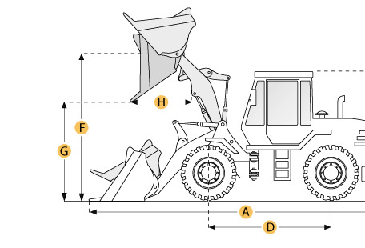

Selected Dimensions

Bucket
G. Dump Clearance at Max Raise | 10.2 ft in | 3110 mm
Dimensions
A. Length with Bucket on Ground | 29.7 ft in | 9050 mm
C. Height to Top of Cab | 11.4 ft in | 3480 mm
D. Wheelbase | 11.5 ft in | 3500 mm
E. Ground Clearance | 1.6 ft in | 480 mm
F. Hinge Pin - Max Height | 14.4 ft in | 4400 mm
H. Reach at Max Lift and Dump | 4.1 ft in | 1250 mm

Specification

Engine
Model | KHD F10 L 413 F
Gross Power | 252.1 hp | 188 kw
Power Measured @ | 2200 rpm
Displacement | 973.5 cu in | 16 L
Torque Measured @ | 1600 rpm
Number of Cylinders | 10
Max Torque | 748.6 lb ft | 1015 Nm
Operational
Operating Weight | 50265.4 lb | 22800 kg
Fuel Capacity | 118.9 gal | 450 L
Hydrauilc System Fluid Capacity | 105.7 gal | 400 L
Engine Oil Fluid Capacity | 7.4 gal | 28 L
Static Tipping Weight | 32848.9 lb | 14900 kg
Turning Radius | 22.6 ft in | 6890 mm
Operating Voltage | 24 V
Alternator Supplied Amperage | 27 amps
Tire Size | 23.5R25
Transmission
Number of Forward Gears | 4
Number of Reverse Gears | 4
Max Speed - Forward | 37.3 mph | 60 km/h
Max Speed - Reverse | 37.3 mph | 60 km/h
Hydraulic System
Relief Valve Pressure | 2610.7 psi | 18000 kPa
Pump Flow Capacity | 99.6 gal/min | 377 L/min
Raise Time | 6.5 sec
Dump Time | 1.6 sec
Lower Time | 4.6 sec
Bucket
Breakout Force | 44961.8 lb | 200 kN
Dump Clearance at Max Raise | 10.2 ft in | 3110 mm
Bucket Width | 9 ft in | 2750 mm
Bucket Capacity - heaped | 5.2 yd3 | 4 m3
Bucket Capacity - struck | 4.4 yd3 | 3.4 m3
Dimensions
Length with Bucket on Ground | 29.7 ft in | 9050 mm
Height to Top of Cab | 11.4 ft in | 3480 mm
Ground Clearance | 1.6 ft in | 480 mm
Wheelbase | 11.5 ft in | 3500 mm
Hinge Pin - Max Height | 14.4 ft in | 4400 mm
Reach at Max Lift and Dump | 4.1 ft in | 1250 mm

