CATERPILLAR 966c Wheel Loader
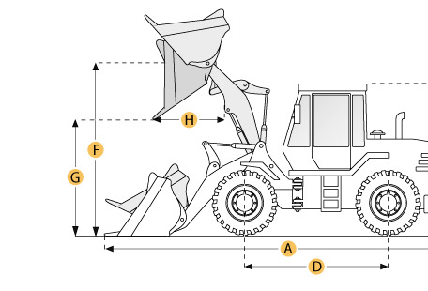

Selected Dimensions
Bucket
G. Dump Clearance at Max Raise | 9.7 ft in | 2950 mm
Dimensions
A. Length with Bucket on Ground | 22.4 ft in | 6830 mm
B. Width Over Tires | 9.1 ft in | 2770 mm
C. Height to Top of Cab | 11.7 ft in | 3560 mm
E. Ground Clearance | 1.3 ft in | 400 mm
F. Hinge Pin - Max Height | 13.7 ft in | 4165 mm
H. Reach at Max Lift and Dump | 2.6 ft in | 790 mm

Specification
Engine
Make | Caterpillar
Model | 3306
Net Power | 170 hp | 126.8 kw
Displacement | 640.7 cu in | 10.5 L
Operational
Operating Weight | 36900 lb | 16737.6 kg
Fuel Capacity | 65 gal | 246 L
Hydrauilc System Fluid Capacity | 52 gal | 197 L
Static Tipping Weight | 28153 lb | 12770 kg
Tire Size | 20.5-25 12 PR(L-3)
Transmission
Number of Forward Gears | 4
Number of Reverse Gears | 4
Max Speed - Forward | 23.6 mph | 38 km/h
Max Speed - Reverse | 28 mph | 45.1 km/h
Hydraulic System
Raise Time | 6.2 sec
Dump Time | 1.6 sec
Lower Time | 3.8 sec
Bucket
Breakout Force | 25578 lb | 113.8 kN
Dump Clearance at Max Raise | 9.7 ft in | 2950 mm
Bucket Width | 9.6 ft in | 2920 mm
Bucket Capacity - heaped | 4.1 yd3 | 3.1 m3
Dimensions
Length with Bucket on Ground | 22.4 ft in | 6830 mm
Width Over Tires | 9.1 ft in | 2770 mm
Height to Top of Cab | 11.7 ft in | 3560 mm
Ground Clearance | 1.3 ft in | 400 mm
Hinge Pin - Max Height | 13.7 ft in | 4165 mm
Reach at Max Lift and Dump | 2.6 ft in | 790 mm

