Caterpillar IT28B Integrated Tool Carrier
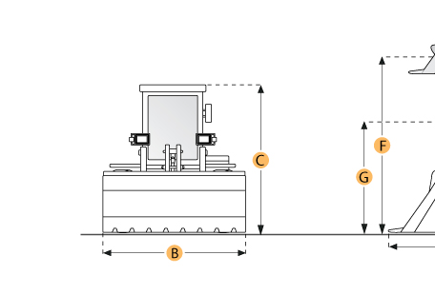

Selected Dimensions
Dimensions
A. Length w/ Bucket on Ground | 22.6 ft in | 6895 mm
C. Height to Top of Cab | 10.5 ft in | 3199 mm
D. Wheelbase | 9.4 ft in | 2870 mm
E. Ground Clearance | 1.1 ft in | 324 mm
F. Hinge Pin Max Height | 12.5 ft in | 3796 mm
G. Dump Clearance at Max Lift | 8.9 ft in | 2726 mm
I. Fork Tine Length | 4 ft in | 1219 mm
J. Length w/ Forks on Ground | 23.6 ft in | 7185 mm
K. Max Lift Height | 12 ft in | 3660 mm
L. Hook Height at Max Lift - standard | 19.2 ft in | 5859 mm
M. Hook Height at Max Lift - extended | 21.8 ft in | 6654 mm
N. Hook Reach at Max Lift - standard | 7.6 ft in | 2313 mm
O. Hook Reach at Max Lift - extended | 9.6 ft in | 2923 mm

Specification
Engine
Make | Caterpillar
Model | 3204
Gross Power | 110 hp | 82 kw
Displacement | 317.3 cu in | 5.2 L
Operational
Operating Weight | 23324.9 lb | 10580 kg
Turning Radius | 18.3 ft in | 5575 mm
Static Tipping Load - Bucket | 16475.1 lb | 7473 kg
Static Tipping Load - Forks | 13166 lb | 5972 kg
Static Tipping Load - Material Handler | 6596.2 lb | 2992 kg
Tire Size | 17.5-25
Transmission
Number of Forward Gears | 4
Number of Reverse Gears | 4
Max Speed Forward | 34.4 mph | 55.4 km/h
Max Speed Reverse | 37.2 mph | 59.9 km/h
Hydraulic System
Raise Time | 6.1 sec
Dump Time | 1.8 sec
Lower Time | 3.6 sec
Bucket
Breakout Force | 23050 lb | 102.5 kN
Bucket Capacity - heaped | 2.2 yd3 | 1.7 m3
Bucket Capacity - struck | 2 yd3 | 1.5 m3
Blade
Width | 7.8 ft in | 2388 mm
Dimensions
Height to Top of Cab | 10.5 ft in | 3199 mm
Wheelbase | 9.4 ft in | 2870 mm
Ground Clearance | 1.1 ft in | 324 mm
Hinge Pin Max Height | 12.5 ft in | 3796 mm
Length w/ Bucket on Ground | 22.6 ft in | 6895 mm
Dump Clearance at Max Lift | 8.9 ft in | 2726 mm
Reach at Max Height and Dump | 3.6 ft in | 1091 mm
Fork Tine Length | 4 ft in | 1219 mm
Length w/ Forks on Ground | 23.6 ft in | 7185 mm
Max Lift Height | 12 ft in | 3660 mm
Hook Height at Max Lift - Standard | 19.2 ft in | 5859 mm
Hook Height at Max Lift - Extended | 21.8 ft in | 6654 mm
Hook Reach at Max Lift - Standard | 7.6 ft in | 2313 mm
Hook Reach at Max Lift - Extended | 9.6 ft in | 2923 mm

