Komatsu D65S-6 Crawler Loader
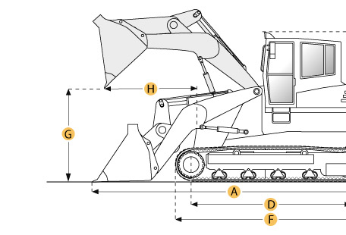

Selected Dimensions

Dimensions
A. Length with Bucket on Ground | 19 ft in | 5790 mm
B. Width to Outside of Tracks | 7.7 ft in | 2355 mm
C. Height to Top of Cab | 9.8 ft in | 2990 mm
G. Clearance at Full Height and Dump | 9 ft in | 2730 mm
H. Reach at Dump Height | 4.3 ft in | 1300 mm
Undercarriage
I. Track Gauge | 74 in | 1880 mm

Specification

Engine
Make | Cummins
Model | NH220-CI
Net Power | 160 hp | 119.3 kw
Displacement | 743 cu in | 12.2 L
Operational
Operating Weight | 39683.2 lb | 18000 kg
Fuel Capacity | 74 gal | 280 L
Cooling System Fluid Capacity | 14.5 gal | 55 L
Static Tipping Load | 11300 lb | 5125.6 kg
Breakout Force - Std Bucket | 14020 lb | 62.4 kN
Bucket Capacity - heaped | 2.4 yd3 | 1.8 m3
Max Speed | 6.1 mph | 9.8 km/h
Undercarriage
Track Shoe Width | 18.1 in | 460 mm
Number of Track Rollers per Side | 6
Length of Track on Ground | 8.6 ft in | 2635 mm
Ground Pressure | 10.5 psi | 72.6 kPa
Track Gauge | 74 in | 1880 mm
Dimensions
Length with Bucket on Ground | 19 ft in | 5790 mm
Width to Outside of Tracks | 7.7 ft in | 2355 mm
Height to Top of Cab | 9.8 ft in | 2990 mm
Clearance at Full Height and Dump | 9 ft in | 2730 mm
Reach at Dump Height | 4.3 ft in | 1300 mm

