Kawasaki 85ZA Wheel Loader
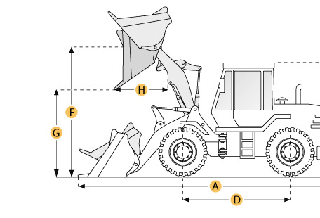

Selected Dimensions
Bucket
G. Dump Clearance at Max Raise | 9.9 ft in | 3015 mm
Dimensions
A. Length with Bucket on Ground | 26.3 ft in | 8010 mm
C. Height to Top of Cab | 11.4 ft in | 3475 mm
D. Wheelbase | 10.8 ft in | 3300 mm
H. Reach at Max Lift and Dump | 3.8 ft in | 1145 mm

Specification
Engine
Make | Nissan
Model | PE6T34
Net Power | 216 hp | 161.1 kw
Power Measured @ | 2200 rpm
Displacement | 712.1 cu in | 11.7 L
Aspiration | diesel w/ turbo
Operational
Operating Weight | 43651.5 lb | 19800 kg
Turning Radius | 21.8 ft in | 6650 mm
Tire Size | 26.5-25-20PR(L3)
Transmission
Number of Forward Gears | 4
Number of Reverse Gears | 4
Max Speed - Forward | 21.1 mph | 34 km/h
Max Speed - Reverse | 21.6 mph | 34.7 km/h
Hydraulic System
Raise Time | 6.3 sec
Dump Time | 1.4 sec
Lower Time | 3.5 sec
Bucket
Breakout Force | 4172.5 lb | 18.6 kN
Dump Clearance at Max Raise | 9.9 ft in | 3015 mm
Bucket Capacity - heaped | 5 yd3 | 3.8 m3
Bucket Capacity - struck | 4.3 yd3 | 3.3 m3
Dimensions
Length with Bucket on Ground | 26.3 ft in | 8010 mm
Height to Top of Cab | 11.4 ft in | 3475 mm
Wheelbase | 10.8 ft in | 3300 mm
Reach at Max Lift and Dump | 3.8 ft in | 1145 mm
KAWASAKI KLD85Z Выпуск 1974-82 г.
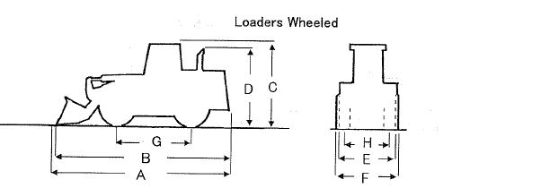
ОСНОВНЫЕ ХАРАКТЕРИСТИКИ  Рабочий вес, кг: 17950  Объем стандартного ковша, m3: 3.1  РАЗМЕРЫ  Длина общая, mm (A): 7800  Длина общая, mm (B): 7555  Общая высота, mm (C): 3425(CNP)  Общая высота, mm (D): N/A  Габаритная ширина, mm (E): 2770  Габаритная ширина, mm (F): 2950  Колесная база, mm: 3200  Протектор, mm: 2170  ДВИГАТЕЛЬ  Марка двигателя: NSN  Модель двигателя: PD6T04  Мощность (KW(PS)/rpm): 158.1(215)/2200  Количество цилиндров: 6  Диаметр поршня, mm: 125x140  Литраж,(ltr): 10.3 |  | ТРАНСМИССИЯ  Количество скоростей (F/R): 4/2  Максимальная скорость движения вперед (км/ч): 34.0  Максимальная скорость движения назад (км/ч): 14.0  ШИНЫ  Размер: 23.5-25  Слойность: 16  Рулевая  Тип: ATC  ПРОИЗВОДИТЕЛЬНОСТЬ  Максимальный радиус поворота (mm): 6200  Высота погрузки (mm): 2900(E/G),2720(T/H)  Дальность погрузки (mm): 1025(E/G), 1115(T/H)  Максимальный рабочий угол (deg): 25  ПРОЧИЕ  Топливный бак, л: 230  Емкость картера, л: 25

