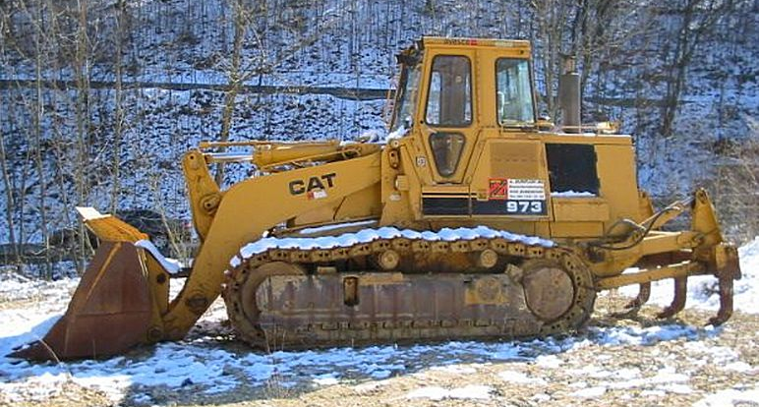
16-264 Caterpillar 973 гусеничный гидравлический погрузчик с многозубым рыхлителем ёмк. ковша 2.8 м3, Н погр. 3.34 м, рабочий вес 25 тн, Cat 3306 210 лс, 10.3 км/час, 6884 экз. США, Франция, Япония 1982-99 г.

The Caterpillar 973 crawler loader was introduced in 1982 in the USA, Japan, and France.

Features
The 973 has a 3306 direct injection turbocharged, six-cylinder engine producing 210 flywheel horsepower (FWHP). It has a hydrostatic transmission. It comes standard with an electronic monitoring system, sealed and lubricated tracks, an oscillating undercarriage, and a Z-bar linkage.
The 973 was manufactured in the USA, with a 26Z or 32Z serial number prefix; in Japan, with a 90L or 91L prefix; and in France, with a 66G or 86G prefix.
The 91L and 26Z units have 26.5-inch (67-cm) track shoes. All other units have 19.7-in (50-cm) shoes.
Both American units have a rollover protection system cab.

Modifications
In 1984 Caterpillar added a new brake control system to the American units, beginning with 26Z00160 and 32Z00610.
Production of 26Z ended in 1984.
Production ended in the USA in 1985.
In 1985 the undercarriage was modified, beginning with 90L00638, 91L00168, 66G00833, and 86G00223. Cat added a single section implement pump and dual setting relief valve, beginning with 66G00761, 86G00217, and 90L00729, and 91L00167.
Production of 66G ended in 1987.
In 1989 a horizontal hydrostatic filter base was added, beginning with 86G00829.
In 1990 Cat changed the track roller frame and shortened the equalizer bar, beginning with 86G01087.
Production ended in Japan in 1996.
Production ended in France in 1999; it was replaced by the Caterpillar 973C.
Based on data from the sales database of Ritchie Bros. Auctioneers, it is estimated that more than 6,800 Caterpillar 963C crawler loaders have been produced.

Highest Serial #
France
66G | 01180
86G | 03570
Japan
90L | 00904
91L | 00277
USA
26Z | 00219
32Z | 00734
Total = 6,884

Погрузчик на гусеничном ходу Caterpillar 973

Эксплуатация
Рабочий вес | 24902 кг
Объем топлива | 356 л.
Объем жидкости гидравлической системы | 60 л.
Статическая опрокидывающая нагрузка | 16788 кг
Усилие отрыва ковша в сложенном состоянии | 213.4 кН
Емкость ковша до краёв | 2.4 м3
Емкость ковша с верхом | 2.8 м3
Максимальная скорость | 10.3 км/ч

Ходовая часть
Ширина башмака гусеничной ленты | 500 мм
Количество подшипников качения с каждой стороны | 7
Длина гусеничной ленты на уровне земли | 2917 мм
Площадь соприкосновения с грунтом | 2.9 м2
Удельное давление на грунт | 83 кПа
Ширина колеи | 2080 мм

Размеры
Длина с ковшом на уровне земли | 7123 мм
Ширина до наружной стороны гусеничной ленты | 2580 мм
Высота до верхней части кабины | 3423 мм
Клиренс | 456 мм
Клиренс при полной высоте и разгрузке | 3340 мм
Вылет при высотной разгрузке | 1328 мм

Двигатель
Производитель | Caterpillar
Модель | 3306
Эффективная мощность | 156.6 кВт
Объем двигателя | 10.5 л.

Гидравлика
Время подъема | 7.4 сек.
Время разгрузки | 1.4 сек.
Время опускания | 2.6 сек.

Dimensions
A Length with Bucket on Ground 23.37 ft in
B Width to Outside of Tracks 9.04 ft in
C Height to Top of Cab 11.24 ft in
E Ground Clearance 1.5 ft in
G Clearance at Full Height and Dump 10.96 ft in
H Reach at Dump Height 4.36 ft in

Undercarriage
D Length of Track on Ground 9.58 ft in
I Track Gauge 81.89in

Specifications

Engine

Engine Make Caterpillar

Engine Model 3306

Net Power 210 hp

Displacement 640.8 cu in

Operational

Operating Weight 56292.9l b

Fuel Capacity 94.1 gal

Hydraulic System Fluid Capacity 15.9 gal

Static Tipping Load 37011.3lb

Breakout Force - Std Bucket 47981 lb

Bucket Capacity – struck 3.2 yd3

Bucket Capacity – heaped 3.7 yd3

Max Speed 6.5mph

Undercarriage

Track Shoe Width 26.6 in

Number of Track Rollers per Side 7

Length of Track on Ground 9.6ft in

Ground Contact Area 6107.1in2

Ground Pressure 9.2psi

Track Gauge 81.9in

Hydraulic

Raise Time 7.4 sec

Dump Time 1.4 sec

Lower Time 2.6 sec

Dimensions

Length with Bucket on Ground 23.4ft in

Width to Outside of Tracks 9.1ft in

Height to Top of Cab 11.3ft in

Ground Clearance 1.5ft in

Clearance at Full Height and Dump 11ft in

Reach at Dump Height 4.4ft in

