Caterpillar 966R Wheel Loader
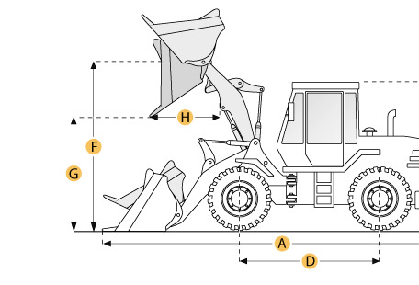

Selected Dimensions
Bucket
G. Dump Clearance at Max Raise | 9.7 ft in | 2959 mm
Dimensions
A. Length with Bucket on Ground | 22.6 ft in | 6883 mm
B. Width Over Tires | 9.1 ft in | 2770 mm
C. Height to Top of Cab | 10.8 ft in | 3280 mm
D. Wheelbase | 10.2 ft in | 3100 mm
E. Ground Clearance | 1.3 ft in | 399 mm
F. Hinge Pin - Max Height | 13.1 ft in | 3990 mm
H. Reach at Max Lift and Dump | 3.3 ft in | 991 mm

Specification
Engine
Make | 2236
Model | 3306
Gross Power | 170.3 hp | 127 kw
Displacement | 640.7 cu in | 10.5 L
Operational
Operating Weight | 36890 lb | 16733 kg
Fuel Capacity | 65 gal | 246 L
Hydrauilc System Fluid Capacity | 52 gal | 197 L
Static Tipping Weight | 27941.4 lb | 12674 kg
Turning Radius | 22.3 ft in | 6782 mm
Tire Size | 23.5-25
Transmission
Number of Forward Gears | 4
Number of Reverse Gears | 4
Max Speed - Forward | 21.7 mph | 34.9 km/h
Max Speed - Reverse | 24.2 mph | 38.9 km/h
Hydraulic System
Raise Time | 6.2 sec
Dump Time | 1.6 sec
Lower Time | 3.8 sec
Bucket
Breakout Force | 25910 lb | kN
Dump Clearance at Max Raise | 9.7 ft in | 2959 mm
Bucket Width | 9.6 ft in | 2921 mm
Bucket Capacity - heaped | 4.1 yd3 | 3.1 m3
Bucket Capacity - struck | 3.4 yd3 | 2.6 m3
Dimensions
Length with Bucket on Ground | 22.6 ft in | 6883 mm
Width Over Tires | 9.1 ft in | 2770 mm
Height to Top of Cab | 10.8 ft in | 3280 mm
Ground Clearance | 1.3 ft in | 399 mm
Wheelbase | 10.2 ft in | 3100 mm
Hinge Pin - Max Height | 13.1 ft in | 3990 mm
Reach at Max Lift and Dump | 3.3 ft in | 991 mm

