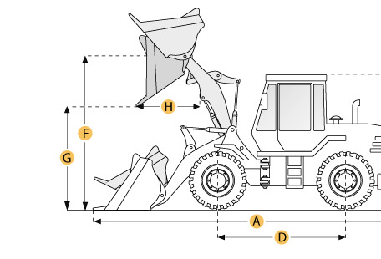

Selected Dimensions
Bucket
G. Dump Clearance at Max Raise | 10.1 ft in | 3070 mm
Dimensions
A. Length with Bucket on Ground | 26.3 ft in | 8020 mm
B. Width Over Tires | 9.3 ft in | 2845 mm
C. Height to Top of Cab | 11.1 ft in | 3375 mm
D. Wheelbase | 10.5 ft in | 3200 mm
E. Ground Clearance | 1.5 ft in | 450 mm
F. Hinge Pin - Max Height | 13.4 ft in | 4090 mm
H. Reach at Max Lift and Dump | 3.7 ft in | 1120 mm

Specification
Engine
Make | Komatsu
Model | SA6D108E
Displacement | 436.3 cu in | 7.2 L
Number of Cylinders | 6
Operational
Operating Weight | 42218.5 lb | 19150 kg
Fuel Capacity | 75.8 gal | 287 L
Turning Radius | 22.1 ft in | 6730 mm
Transmission
Number of Forward Gears | 4
Number of Reverse Gears | 4
Max Speed - Forward | 18 mph | 28.9 km/h
Max Speed - Reverse | 18.1 mph | 29.1 km/h
Bucket
Dump Clearance at Max Raise | 10.1 ft in | 3070 mm
Bucket Width | 9.6 ft in | 2925 mm
Dimensions
Length with Bucket on Ground | 26.3 ft in | 8020 mm
Width Over Tires | 9.3 ft in | 2845 mm
Height to Top of Cab | 11.1 ft in | 3375 mm
Ground Clearance | 1.5 ft in | 450 mm
Wheelbase | 10.5 ft in | 3200 mm
Hinge Pin - Max Height | 13.4 ft in | 4090 mm
Reach at Max Lift and Dump | 3.7 ft in | 1120 mm
New & Used Heavy Equipment http://www.ritchiespecs.com/specification?type=Constructi&category=Wheel+Loader&make=Komatsu&model=WF350-3&modelid=91668#ixzz4vm1gU3MW

