LIEBHERR l566 2plus2 Wheel Loader
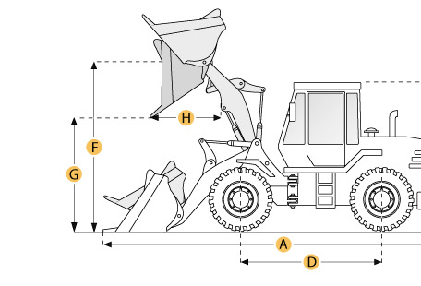

Selected Dimensions

Bucket
G. Dump Clearance at Max Raise | 10.6 ft in | 3240 mm
Dimensions
A. Length with Bucket on Ground | 29.2 ft in | 8912 mm
C. Height to Top of Cab | 11.6 ft in | 3550 mm
D. Wheelbase | 11.7 ft in | 3580 mm
E. Ground Clearance | 1.9 ft in | 565 mm
F. Hinge Pin - Max Height | 14.3 ft in | 4360 mm

Specification

Engine
Make | Liebherr
Model | D 936 L A6
Gross Power | 254.8 hp | 190 kw
Displacement | 642 cu in | 10.5 L
Max Torque | 907.2 lb ft | 1230 Nm
Aspiration | turbo-charged
Operational
Operating Weight | 49604 lb | 22500 kg
Fuel Capacity | 105.7 gal | 400 L
Hydrauilc System Fluid Capacity | 68.7 gal | 260 L
Engine Oil Fluid Capacity | 11.4 gal | 43 L
Cooling System Fluid Capacity | 13.7 gal | 52 L
Front Axle/Diff Fluid Capacity | 13.5 gal | 51 L
Rear Axle/Diff Fluid Capacity | 13.5 gal | 51 L
Static Tipping Weight | 34300 lb | 17690 kg
Operating Voltage | 24 V
Alternator Supplied Amperage | 80 amps
Rear Axle Oscillation | 26 degrees
Tire Size | 26.5R25
Transmission
Type | hydrostatic
Number of Forward Gears | 3
Number of Reverse Gears | 3
Max Speed - Forward | 24.9 mph | 40 km/h
Max Speed - Reverse | 24.9 mph | 40 km/h
Hydraulic System
Pump Type | Load-sensing swash plate type variable flow pump with output and flow control and pressure cut-off in the control block
Relief Valve Pressure | 5076.3 psi | 35000 kPa
Pump Flow Capacity | 76.6 gal/min | 290 L/min
Raise Time | 5.5 sec
Dump Time | 2 sec
Lower Time | 3.5 sec
Bucket
Breakout Force | lb | 200 kN
Dump Clearance at Max Raise | 10.6 ft in | 3240 mm
Bucket Width | 9.8 ft in | 3000 mm
Bucket Capacity - heaped | 5.2 yd3 | 4 m3
Dimensions
Length with Bucket on Ground | 29.2 ft in | 8912 mm
Height to Top of Cab | 11.6 ft in | 3550 mm
Ground Clearance | 1.9 ft in | 565 mm
Wheelbase | 11.7 ft in | 3580 mm
Hinge Pin - Max Height | 14.3 ft in | 4360 mm

