KOMATSU wa75-3 Wheel Loader
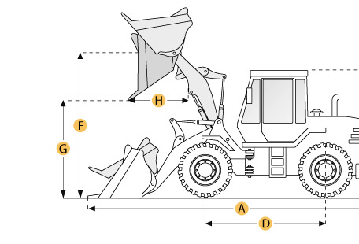

Selected Dimensions
Bucket
G. Dump Clearance at Max Raise | 8.4 ft in | 2565 mm
Dimensions
A. Length with Bucket on Ground | 17.7 ft in | 5390 mm
C. Height to Top of Cab | 8.7 ft in | 2650 mm
D. Wheelbase | 6.6 ft in | 2000 mm
E. Ground Clearance | 1.5 ft in | 460 mm
F. Hinge Pin - Max Height | 10.5 ft in | 3205 mm
H. Reach at Max Lift and Dump | 2.9 ft in | 890 mm

Specification
Engine
Make | Komatsu
Model | 4D 98E
Net Power | 57 hp | 42.5 kw
Power Measured @ | 2500 rpm
Displacement | 202.5 cu in | 3.3 L
Torque Measured @ | 1600 rpm
Max Torque | 154.9 lb ft | 210 Nm
Number of Cylinders | 4
Operational
Operating Weight | 10692.4 lb | 4850 kg
Fuel Capacity | 23.8 gal | 90 L
Hydrauilc System Fluid Capacity | 25.1 gal | 95 L
Engine Oil Fluid Capacity | 2.5 gal | 9.4 L
Cooling System Fluid Capacity | 3.2 gal | 12.3 L
Front Axle/Diff Fluid Capacity | 1.6 gal | 6.1 L
Rear Axle/Diff Fluid Capacity | 1.7 gal | 6.5 L
Static Tipping Weight | 8267.3 lb | 3750 kg
Turning Radius | 12.4 ft in | 3770 mm
Operating Voltage | 12 V
Alternator Supplied Amperage | 80 amps
Rear Axle Oscillation | 24 degrees
Tire Size | 405/70 R18 SPT 9
Transmission
Type | hydrostatic
Number of Forward Gears | 2
Number of Reverse Gears | 2
Max Speed - Forward | 12.4 mph | 20 km/h
Hydraulic System
Pump Type | Closed Hydraulic Circuit
Relief Valve Pressure | 2973.3 psi | 20500 kPa
Pump Flow Capacity | 16.9 gal/min | 64.1 L/min
Raise Time | 4.9 sec
Dump Time | 1 sec
Lower Time | 2.6 sec
Bucket
Breakout Force | 10925.7 lb | 48.6 kN
Dump Clearance at Max Raise | 8.4 ft in | 2565 mm
Bucket Width | 6.4 ft in | 1950 mm
Bucket Capacity - heaped | 1 yd3 | 0.8 m3
Dimensions
Length with Bucket on Ground | 17.7 ft in | 5390 mm
Height to Top of Cab | 8.7 ft in | 2650 mm
Ground Clearance | 1.5 ft in | 460 mm
Wheelbase | 6.6 ft in | 2000 mm
Hinge Pin - Max Height | 10.5 ft in | 3205 mm
Reach at Max Lift and Dump | 2.9 ft in | 890 mm

